Air-Ice-Ocean Coupling During a Strong Mid-Winter Cyclone Part 1: Coupled Dynamic Interactions in Observations and a Model

D. M. Watkins1, P. O. G. Persson2, T. Stanton3, A. Solomon2, J. K. Hutchings4 J. Haapala5, G. Svensson6

1Center for Fluid Mechanics, Brown University, Providence, RI, USA. 2Cooperative Institute for Research in Environmental Sciences, University of Colorado, Boulder CO and NOAA/Physical Sciences Laboratory, Boulder CO, USA. 3Moss Landing Marine Laboratories and Naval Postgraduate School, CA, USA. 4College of Earth Ocean and Atmospheric Sciences, Oregon State University, Corvallis, OR, USA. 5Finnish Meteorological Institute, Helsinki, Finnland. 6Stockholm University, Stockholm, Sweden

Corresponding author: Daniel Watkins ([daniel_watkins@brown.edu](mailto:daniel_watkins@brown.edu))

Key Points:

* A pair of cyclones crossed the Multidisciplinary drifting Observatory for the Study of the Arctic Climate in short succession during midwinter 2020
* The detailed, multi-platform observations enable characterization of coupled air-ice-ocean interactions during the cyclones
* The development of a low-level atmospheric jet is a key factor in the spatially-varying sea ice and ocean response to the cyclone

Abstract

Arctic cyclones are key drivers of sea ice and ocean variability. During the 2019-2020 Multidisciplinary drifting Observatory for the Study of Arctic Climate (MOSAiC) expedition, joint observations of the coupled air-ice-ocean system were collected at a range of spatial scales. Here, we present observations of a pair of strong mid-winter cyclones that impacted the MOSAiC site as it drifted in the central Arctic pack ice. The sea ice dynamical response showed spatial structure at the scale of the atmospheric wind field. Internal ice stress and the ocean stress play significant roles, including producing timing offsets between the atmospheric forcing and the ice response and post-cyclone inertial ringing in the ice and ocean. The results show a structured response of sea ice motion and deformation to cyclone passage, and that the ice motion then forces the upper ocean currents through frictional drag. The strongest impacts to the sea ice and ocean from the cyclone passing occur as a result of the surface expression of a strong low-level jet behind the cold front. The impacts of the cyclone are prolonged through the coupled ice-ocean inertial response. The local impacts of the ~120 km wide jet occur over a 12 hour period, meaning that these impacts occur at smaller spatial scales and faster time scales than typical satellite observations and coupled Earth system models can resolve.

**Plain Language Summary**

Arctic winter cyclones are an important part of the Arctic climate system. Yet, due to sparse observations, processes of the coupled sea ice-ocean response to cyclones are not fully understood. During the 2019-2020 Multidisciplinary drifting Observatory for the Study of Arctic Climate (MOSAiC) expedition, observations of the atmosphere, sea ice, and ocean were collected at a range of spatial scales. In January and February 2020, a pair of cyclones passed nearly directly over the MOSAiC observatory, making it possible to study the cyclone structure and the associated sea ice and ocean response in detail. In this study, we describe the storm structure using data from surface weather stations, weather balloons, radar, and a reanalysis model. We then describe the sea ice motion using a large set of GPS buoys and ice radar images. Finally, we examine the upper ocean currents and structure using ocean buoy data. We find that the most important part of the storm structure for the sea ice is the development of a low-level jet, a narrow region of fast moving air that eventually circles around the storm. The sudden change in sea ice drift speed at the time that the low-level jet passes overhead produces a pulse of momentum into the ocean. Circular motion in the ocean initiated by this pulse of momentum continue for days following the passage of the storm, prolonging its effects.

1 Introduction

The physical environment in the Central Arctic consists of dynamically and thermodynamically coupled processes between the atmosphere, ice, and upper ocean (Brenner et al., 2023; Deser et al., 2015; Petty et al., 2016; Webster et al., 2019). Sea ice, and its accompanying snow cover, regulates the linkage between atmosphere and ocean through dynamics (lead opening and closing, evolving roughness of the air-ice and ice-ocean interfaces) and through thermodynamics as the ice and snow packs grow and melt (Overland, 1985; Pinto et al., 2003; von Albedyll et al., 2022). In turn, the stability of the atmospheric and ocean boundary layers governs the evolution of turbulent eddies, affecting the magnitude of turbulent fluxes of heat and momentum (Lüpkes et al., 2008; Lüpkes and Gryanik, 2015; Taylor et al., 2018).

Arctic winter cyclones play a large role in the air-ice-ocean system. Cyclone passage results in a pulse of momentum, heat, and moisture into the ice-ocean system. They represent major sources of poleward heat and moisture transport during Arctic winter (Fearon et al., 2021) and are a major contributor to net snow accumulation (Webster et al., 2019). Cyclone passage is often accompanied by strong sea ice deformation (Itkin et al., 2017; Lindsay, 2002; Oikkonen et al., 2017) and enhanced ocean mixing (Meyer, Fer, et al., 2017; Meyer, Sundfjord, et al., 2017). Cyclone impacts on sea ice depend on time of year, cyclone strength and evolutionary stage, location within the Arctic, location relative to the ice edge and coast, and the sea ice state (Aue et al., 2022).

The direct dynamic impacts of cylones on the sea ice momentum equation (e.g., Hibler, 1979; Hunke et al., 2015) are transferred through the atmospheric stress term, $τ_{a}$:

$$\begin{aligned}m \frac{Du}{Dt}= -mfk×u+ τ_{a}+ τ_{o}-mg ∇H+∇⋅σ \#\left(1\right)\end{aligned}$$

The left side of (1) is the rate of change of the ice momentum with approximately constant mass $m$ (snow and sea ice mass per unit area), where $u$ is the sea ice velocity. The sum of forces on the right-hand-side terms consists of the stresses on the ice due to the Coriolis force, where $f$ is the Coriolis parameter, the atmosphere and ocean stress vectors $τ_{a}$ and $τ_{o}$, the effect of gravity down the slope of the ocean surface, and the divergence of the internal stress tensor. The latter term represents energy loss due to friction between the floes and conversion of kinetic energy to potential energy, parametrized in terms of bulk and shear viscosities and ice strength. The coupled inertial response following the storm passage can prolong its dynamic effects (Haller et al., 2014).

The structure of the wind field within a cyclone imparts spatial gradients in the surface stresses. As a result, the thermodynamic and dynamic sea ice response varies relative to the position of the central low and the orientation of the storm track (e.g., Brümmer, 2003; Haapala et al., 2005; Kriegsmann and Brümmer, 2014; Overland and Pease, 1982). Estimates of cyclone structure and impacts based on composite analysis are sensitive to choices made in cyclone identification (Rae et al., 2017) and to the choice of reanalysis (Vessey et al., 2020). Nevertheless it is clear that sea ice impacts have spatial structure, with dependence on distance from the storm center (Kriegsmann and Brümmer, 2014) and position relative to the storm track (Clancy et al., 2022).

Differences in cyclone properties between reanalysis composites can arise from uncertainty in the physics of Arctic cyclones, differences in model implementation (including choice of paramterization schemes), and the lack of long-term in situ observations in the central Arctic relative to the midlatitudes, particularly joint observations of atmosphere, sea ice, and ocean. Thermodynamic air-ice-ocean interactions for cyclones sampled during the Surface Heat and Energy Budget of the Arctic expedition (SHEBA; Uttal et al., 2002) have been analyzed at least in part in numerous studies (e.g., Lindsay, 2002; Persson, 2012; Persson et al., 2017; Richter-Menge et al., 2001; Shaw et al., 2009), primarily in the context of seasonal or annual analysis. Both Lindsay (2002) and Richter-Menge et al., (2001) identify periods of enhanced mid-winter sea ice deformation that coincided with significant cyclone activity; however, the sea ice deformation observations lack sufficient resolution to examine air-ice dynamic coupling in detail. Measurements of sea ice motion and deformation show patterns related to the storm structure (Brümmer et al., 2008; Haller et al., 2014), with ice tending to diverge on average as the cyclone passes. The location of the ice edge and the local history of deformation is an important factor (Oikkonen et al., 2017).

The ocean responses to wind forcing is strongly modulated by seasonal changes in ice thickness, roughness, and concentration (Gallaher et al., 2016; McPhee, 2002, 2008; Meyer, Fer, et al., 2017; Shaw et al., 2009; Stanton et al., 2012; Yang, 2004). Cyclones, and the strong gradients in winds associated with them, result in changes in momentum transfer to the ocean that can excite inertial oscillations in the ocean and ice (Brümmer & Hoeber, 1999; Hunkins, 1967), where the ice moves largely in lock with the ocean in an inertial ringing (Toole et al., 2010). The presence of ice can damp the ocean response (Brenner et al., 2023; Rainville & Woodgate, 2009), however inertial oscillations are observed under consolidated winter ice pack (Martini et al., 2014) and in all seasons. This momentum transfer and the inertial motion enhances mixing in the upper ocean and may also excite internal waves that enhance deeper mixing (McPhee and Kantha, 1989). High wind speeds over sea ice have been observed to produce increased ocean friction velocity (Shaw et al., 2009) and enhanced turbulent dissipation in the upper ocean (Meyer, Fer, et al., 2017). The winter ice cover impedes the inertial behavior and reduces momentum transfer, likely setting the shallow winter mixed layer depth in parts of the Arctic Ocean (Toole et al., 2010). Buoy observations of sea ice drift suggest that the inertial response of the ice has been increasing (Gimbert et al., 2012; Yuan et al., 2022). It has been hypothesized that an increase in sea ice inertial response may arise due to thinning of the ice pack (Gimbert et al., 2012) as well as increased cyclonic activity (Roberts et al., 2015).

To date, the full momentum transfer from wind, through ice to the ocean has not been observed directly on the temporal and spatial scales that clearly define the roles of the spatial structure of a cyclone for the associated ice and ocean response. To that end, we consider the detailed observations of the coupled-air-ice-ocean system obtained during the Multidisciplinary drifting Observatory for the Study of Arctic Climate (MOSAiC) expedition (Shupe et al., 2020; Shupe and Rex, 2022). This study will examine the relative roles of the atmospheric stress, ocean stress (shearing between ice motion and upper-ocean currents), and the internal ice stress (via consideration of sea ice deformation) in the momentum balance from MOSAiC observations during the passage of two atmospheric cyclones that traversed the study area between 30 January and 2 February, 2020. While numerous cyclones occurred during the MOSAiC year (Rinke et al., 2021), these cyclones (and in particular the second cyclone) are of particular interest due to the intensity, as measured by the observed wind speed and minimum sea level pressure, the strong sea ice response, which included the fastest winter drift speeds observed during the MOSAiC drift and strong deformation of the ice pack, and the proximity of the storm track to the MOSAiC observatory. Furthermore, the cyclones occurred during the consolidated ice season in the high Arctic, when the internal ice stress term is expected to be an important part of the response.

The study will highlight the atmospheric features producing the atmospheric stress characteristics, and the impacts of these stress terms on the sea-ice and ocean motion. While the atmospheric stress is generally regarded as the primary forcing mechanism for ice motion, it will be shown that both the internal ice stress and the ocean stress play significant roles in changing the typical air-ice interaction characteristics, including producing timing offsets between the atmospheric forcing and the ice response and producing post-cyclone inertial “ringing” responses in the ice and ocean. The MOSAiC observations and additional data will be described in section 2. Sections 3-5 describe the observations of atmosphere, sea ice, and ocean, respectively. Discussion and conclusions follow in Section 6.

2 Data

The MOSAiC Central Observatory (CO) and its surrounding distributed network (DN) of automated observational platforms and buoys were deployed in residual ice north of the Laptev Sea in early October 2019, and drifted across the Central Arctic during the subsequent winter, entering the Fram Strait in June 2020 (Krumpen et al., 2020). Maps showing the track of the drifting station and more details of the atmospheric, ice, ocean and DN observations along this drift track can be found in a series of MOSAiC overview (Nicolaus et al., 2022; Rabe et al., 2022; Shupe et al., 2022) and domain-specific publications (e.g., Fer et al., 2022; Krumpen et al., 2021; Peng et al., 2023; von Albedyll et al., 2022; Watkins et al., 2023). Figure 1 shows a map of the relative positions of the CO and the DN sites on Jan 31, 2020, at which time the CO was located at 87.5 N, 96.0 E (275 km from the North Pole).

2.1 Atmospheric observations

Atmospheric observations used in this study were made at the CO (both on board the *R/V Polarstern*, and at the “Met City” site located on the ice approximately 400 m from the ship), and at the three “L” sites located 10-20 km from the ship (Figure 1). Key measurements from the *R/V Polarstern* include the 6-hourly rawinsondes providing profiles of temperature, humidity, and horizontal winds, and the vertically-pointing Ka-band radar providing profiles of radar reflectivity and radial velocity. The 30-s radar data profiles were averaged to 10-min time intervals for this study. A DOE/ARM scanning Ka-band radar provided volumes of radar reflectivity and radial velocity every ~12 minutes, providing data for plane-parallel indicator (PPI) displays (Figure 4) characterizing clouds and precipitation. Analyses of fronts and mesoscale features in the time-height cross sections (Figure 5) and horizontal displays relied on standard subjective analyses of thermodynamic (e.g., temperature, virtual potential temperature ($θ_{v}$), equivalent potential temperature $(θ_{e}$)), kinematic (e.g., wind speed and direction), and radar reflectivity observations, not all of which are shown. Changes in $θ_{e}$ and wind direction and minima in SLP were key markers for determining frontal boundaries. The Arctic inversion (AI) was defined as the height of the maximum temperature in each sounding, and varied distinctly as synoptic conditions changed. Surface-based layers of constant $θ_{v}$ defined the surface mixed-layer (SML) depth for each sounding.

Sonic anemometers and basic meteorology sensors at Met City provided time series of temperature, humidity, winds, mean sea level pressure (SLP), and turbulence (including momentum flux) at 3 different levels (nominally 2, 6, and 10 m). Atmospheric Surface Flux Stations (ASFS) located at the three L-sites provided measurements of temperature, humidity, pressure, and 4-component broadband radiative fluxes above the sea ice, and winds and turbulence (including momentum flux) at 3.8 m above the ice. The ASFS and Met City data used in this study are 10-min average values. Unless otherwise stated, the Met City wind and turbulence data shown represents the 10 m values while those at the ASFS represent the 3.8 m height.

Atmospheric stress was obtained through covariance calculations using the 10 Hz three-component ($u,v,w$) measurements from the sonic anemometers at Met City and the ASFS. First, the earth coordinate system is rotated into streamwise coordinates through a double rotation (Kaimal and Finnigan, 1994). The 10-min values of friction velocity $u_{a}^{*}={\left(u_{s}^{'}w^{'}\right)}^{1/2}$ were then obtained from the integration of the cross-spectral density for a 13.65 min window centered on the 10 min period. Here, $u_{s}^{'}$ and $w^{'}$ are perturbation values of the streamwise and vertical wind speeds, respectively. The observed atmospheric stress is then calculated by $τ_{a}=ρ_{a}{u_{a}^{*}}^{2}$, where $ρ_{a}$ is the atmospheric density. More detailed descriptions of the data processing, turbulence calculations and the atmospheric measurements on the *R/V Polarstern*, at Met City, and at the ASFS sites are provided by Shupe et al. (2022) and Cox et al. (2023).

Time series of low-level atmospheric divergence are calculated from the winds at the three L-sites using the assumption that the winds vary linearly between the three sites. With this assumption, the area-averaged low-level atmospheric divergence ${div}_{a}$ can be calculated using the area-normalized divergence theorem and by integrating the winds normal to the sides of the polygon such that

$$\begin{aligned}div_{a} ≈\frac{1}{A}\left[\sum_{i=1}^{n_{s}}{\left({\overline{u}}_{i}{dy}_{i}- {\overline{v}}_{i}{dx}_{i}\right)}\right]\#\left(2\right)\end{aligned}$$

where $n_{s}=3$ is the number of sides, ${\overline{u}}_{i}, \overline{v_{i}}$ are the mean $u$ and $v$ wind components on side *i*, and ($dx_{i}, dy_{i}$) are the component lengths of each side *i*. Because this calculation is sensitive to errors in the installation and manual orientation of the sonic anemometers, we assume that the long-term mean divergence between ASFS sensor alignments is zero, and subtract this mean value from each value in the time series. For this case, the long-term mean divergence was $-1.1×{10}^{-5}s^{-1}$  
 calculated between 30 November, 2019, and 5 February, 2020. Hence, magnitudes of $div_{a}$ larger than $2×{10}^{-5}s^{-1}$ are likely significant.

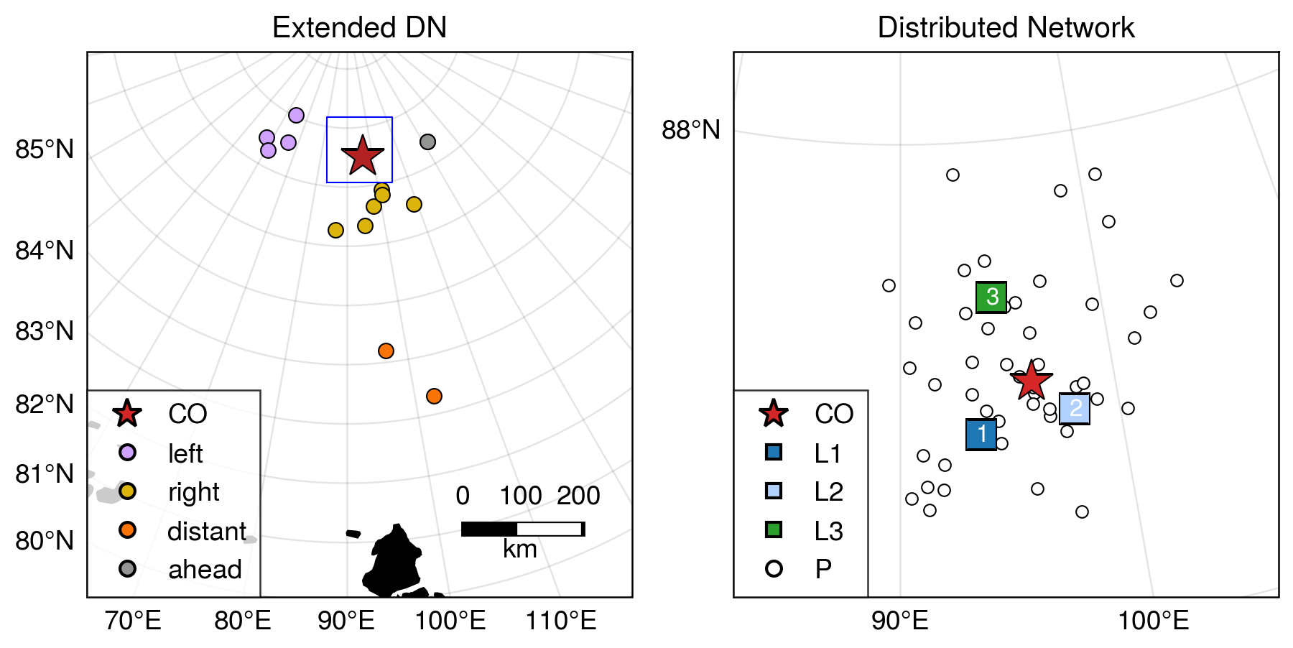

**Figure 1**. MOSAiC domain and instrument locations on 1 February 2020 at 00:00 UTC. Shown are the Central Observatory (red star labeled CO), the 3 “L-sites” with the ASFS, SIMB and AOFB (squares, right hand panel) measuring complete atmospheric, ice and upper-ocean parameters, and the GPS ice buoys (circles) measuring position. Colors of GPS buoys in left panel correspond to groups defined and highlighted in Figures 7 and 9.

2.2 ERA5 atmospheric reanalysis

We supplement the atmospheric observations with 0.25° resolution data from the fifth-generation European Center for Medium-range Weather Forecasting reanalysis (ERA5; Hersbach et al., 2020) obtained from the Copernicus Data Store (Hersbach et al., 2023b, 2023a). Prior to analysis, the data was reprojected on a regular 25 km north polar stereographic grid with central longitude 90°. The ERA5 reanalysis performs well relative to other reanalyses in the Arctic domain (Graham, Cohen, et al., 2019; Graham, Hudson, et al., 2019). ERA5 is known to have a surface warm bias in the Arctic (Wang et al., 2019; Yu et al., 2021); here, we use ERA5 mean sea level pressure and 10-m winds, and 925 hPa temperature and humidity, and we use observational data for near surface temperatures. Rawinsonde and surface observations from the MOSAiC central observatory were assimilated by ERA5, as were surface measurements of temperature and air pressure from numerous meteorological buoys from the MOSAiC Distributed Network. As such, we consider the ERA5 fields to be a reasonable estimate for describing the structure of the storms analyzed here.

2.3 Sea ice observations

An array of drifting buoys comprising the DN (Bliss et al., 2023) track sea ice motion and deformation. Figure 1b shows the positions of the DN sites on February 1st, 2020 within 60 km of the central observatory. An additional 13 buoys comprise the “extended DN” and provide information on larger-scale ice motion (Figure 1a, colored circles). Each buoy reports positions via the Global Positioning System (GPS) with time resolution ranging from 10 minutes to 4 hours; the majority of buoys sampled at least once every hour. We only use buoys with time resolution of three hourly or less. Initial buoy processing is described in Bliss et al. (2023). In addition, anomalous points due to large random GPS errors were identified and removed by calculating the Z-score of the minimum of velocities estimated by forward and backward differences relative to a 3 day centered window. Observations were aligned to a 30-minute grid using natural cubic spline interpolation. During the study period, 64 P-sites were operating, out of which 57 fulfill study criteria. An additional 11 sites (including the L-sites and the CO) contain multiple instruments. We selected a reference buoy from each of these sites, preferring those with higher sampling rate and data precision (Table S1). Choice of reference buoys in most cases is arbitrary, as the buoys at each site are closely situated.

The trajectories of the DN sites provide information about the divergence, shear and vorticity of sea ice inside the Distributed Network. We calculate strain-rate components using a Green’s Theorem method, following Hutchings et al. (2011, errata 2018). The area over which deformation is estimated can be varied depending on sites chosen to surround the region of interest. We consider deformation on a variety of scales including: the triangle with L-sites at its vertices, a set of 5 polygons with length scales of 15-30 km covering the DN, a polygon enclosing the full DN with length scale 57 km, (Figure 10) and two polygons for the left and right sections of the ExDN (Figure 9). Hence, the DN Full array is an estimate of average deformation within the DN, while the smaller polygons in Figure 10 give an indication of the variability within the array.

2.4 Sea ice radar imaging

Local sea ice deformation observations were obtained from a ship radar image digitizing system. The system was connected to the 9.4 GHz X-band radar mounted at the roof of the *R/V Polarstern* (Hessner et al., 2019). Images of sea ice backscattering were collected with 8.3 m resolution every 2.5 seconds. Due to low incidence angle and shadowing effect of sea ice ridges, maximum range of sea ice imaging was about 10 km.

2.5 Upper-ocean turbulence and current measurements

Ocean timeseries observations were made from Autonomous Ocean Flux Buoys (AOFBs; Stanton et al., 2012) adjacent to the CO Met Tower and from the three L site ice floes 10-20 km out from the CO. Data from the buoys were uploaded to a server at the Naval Postgraduate School (NPS) twice a day (<https://www.oc.nps.edu/~stanton/fluxbuoy/deploy/deploy.html>) providing long term unattended observations until consumed by the dynamic ice floes encountered during the MOSAiC drift. Each of these buoys supported a 4 m depth eddy-correlation turbulence sensor package providing direct heat, salt and momentum fluxes every 2 hours from 35 minute ensemble co-spectra of the 2 Hz sampled 3-component velocity, temperature and conductivity timeseries. Ocean friction velocities $u_{o}^{*}={\left({\left\langle u^{'}w^{'}\right\rangle }^{2}+{\left\langle v^{'}w^{'}\right\rangle }^{2}\right)}^{\frac{1}{2}}$ from these co-spectra are used to infer the upper ocean stress ($ρ_{o}{u_{o}^{*}}^{2}$) at 4 m. A co-located Acoustic Doppler Current Profiler (ADCP) measured current profiles from 6 m to 80 m depth sampling every at 2.5 s and every 2 m in depth, and reporting 15 minute ensembles with <1 cm s-1 noise levels. Earth-referenced absolute current profiles were calculated from the instrument-coordinate ADCP measurements by first rotating the component profiles into true north coordinates using declination-corrected flux gate compass measurements in the ADCP and flux package, and, where possible, comparison with shipboard and ASFS GPS-based heading observations. The AOFB / ice floe horizontal motion was then removed using the AOFB GPS timeseries to form absolute u/v vector current profiles.

In this study we use ocean measurements from the CO site adjacent to the main Met Tower. Water density profiles were calculated from the intermittent ships CTD and microstructure profiling program at the CO. Difficult operating conditions during this period of very high winds limited CTD sampling at the CO to as little as once per day. Seasonal mixed layer depths are estimated from the depth in each profile where there is a 0.2 Kg m-3 potential density increase from the 8 m near surface values. These sparse-in-time mixed layer depths are linearly interpolated depths and smoothed with a 12 hr period filter to estimate the depth of the top of the strong halocline observed across much of the Arctic. A much more sensitive density threshold of 0.01 Kg m-3 is used as an indicator of the base of the active surface boundary layer in the analysis in section 5.

3 Atmospheric structure and evolution

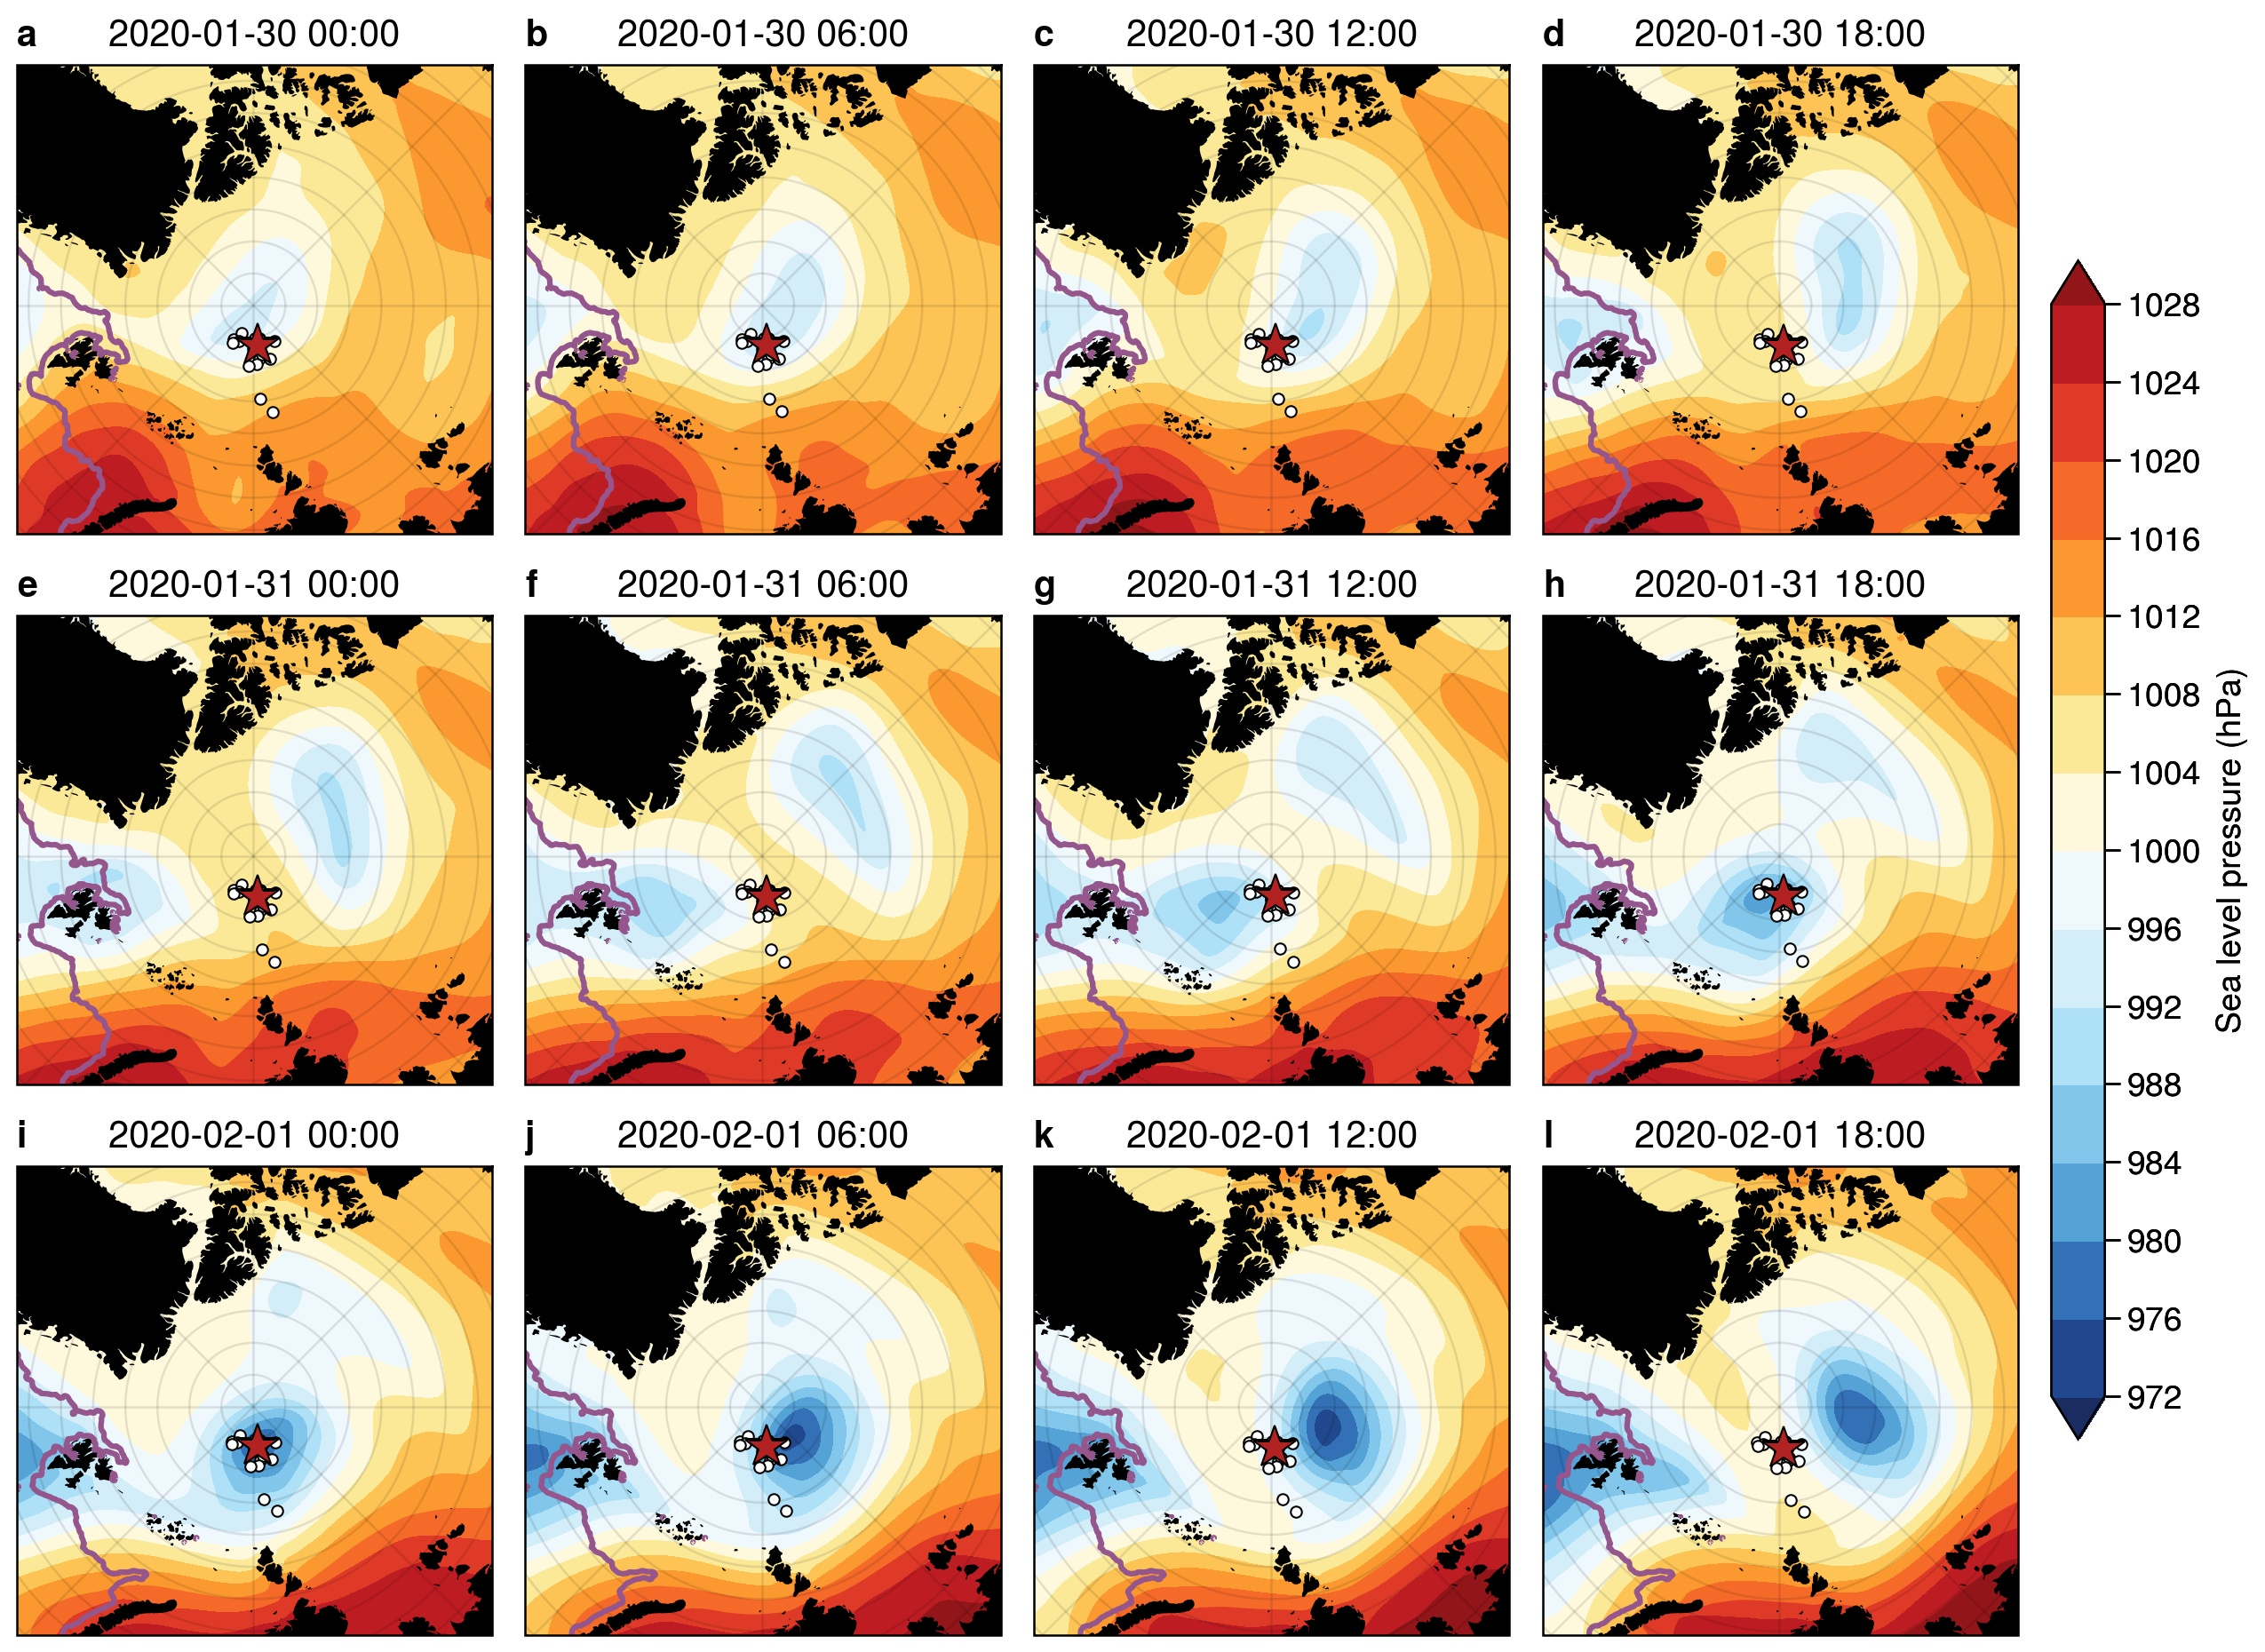3.1 Synoptic evolution

**Figure 2**. Sequence of ERA5 mean sea-level pressure (SLP) analyses at 6-hour intervals from 30 January 00:00 UTC to 1 February 18:00 UTC centered on the North Pole. The red star indicates the location of the CO, and the black dots show the buoys in the DN. The position of the ice edge from the daily NSIDC 12.5 km AMSR2 sea ice concentration (SIC), defined as the 15% SIC isoline, is indicated with a purple line.

Two cyclones crossed the MOSAiC domain in short succession between January 29th and February 1st, 2020 (Figure 2). The first low (C1) developed along the NE coast of Greenland on 29 January, strengthening slightly as it moved northward over the North Pole. Soundings at the *R/V Polarstern* suggest that a warm front/cold front couplet developed with the system (Figure 5) and that the warm sector passed over the MOSAiC domain. As this first cyclone was passing the MOSAiC domain, a second cyclone (C2) developed along the west coast of Svalbard on 30 January and strengthened along Svalbard’s north coastline as it moved northward. While C1 only deepened by about 7 hPa along its track, C2 deepened by nearly 20 hPa, becoming one of the deepest cyclones to pass over the MOSAiC domain during the year. The observed SLP minimum (974 hPa) in the MOSAiC domain during C2 was 4 hPa lower than the minimum central pressure in the ERA5 fields, indicating that the observed cyclone was slightly stronger than in the reanalysis. A warm front/cold front couplet also developed with this system, both of which passed over the MOSAiC observatory.

3.2 Key mesoscale structures

Figure 3 shows an atmospheric frontal analysis of C2 based on the 6-hourly ERA-5 mean sea-level pressure and 925 hPa equivalent potential temperature ($θ_{e}$) and winds. In this and following figures, references to cardinal directions are relative to the CO. The maps are oriented so that north from the CO is in the positive y direction and east is in the positive x direction; note that the North Pole is 267 km north of the CO, so the direction of true north will vary substantially throughout the figure. The storm has clear spatial structure, with a cold sector to the left of the storm track and a warm sector to the right. The surface warm front passes over the CO (red star) on 31 January between 14 UTC and 16 UTC, while the cold front passes over the CO on 1 February near 00 UTC (aloft) and near 02 UTC (surface). The surface low passes very close to the CO but just to its west and north, such that the CO is initially in the warm sector. Strong low-level wind speeds indicating a low level jet (LLJ) initially occur in the warm sector between the warm front and the cold front aloft. By 1 February 00 UTC (Figure 3b), a LLJ (indicated here by the 16 m/s isotach) encircles the surface low and remains as a nearly axisymmetric annulus through the rest of the time period as the system occludes with bands of warm and cold air wrapping around the low center. Figure 2 suggests that C2 was more axisymmetric (circular) than C1. While the second cyclone is quasi-symmetric initially and becomes even more symmetric as it strengthens, the first cyclone starts out more elongated and becomes even more so with time. The first cyclone appears eventually to be absorbed into the second cyclone. We hypothesize that the circularity of the storm is an important factor in the development of the mesoscale LLJ.

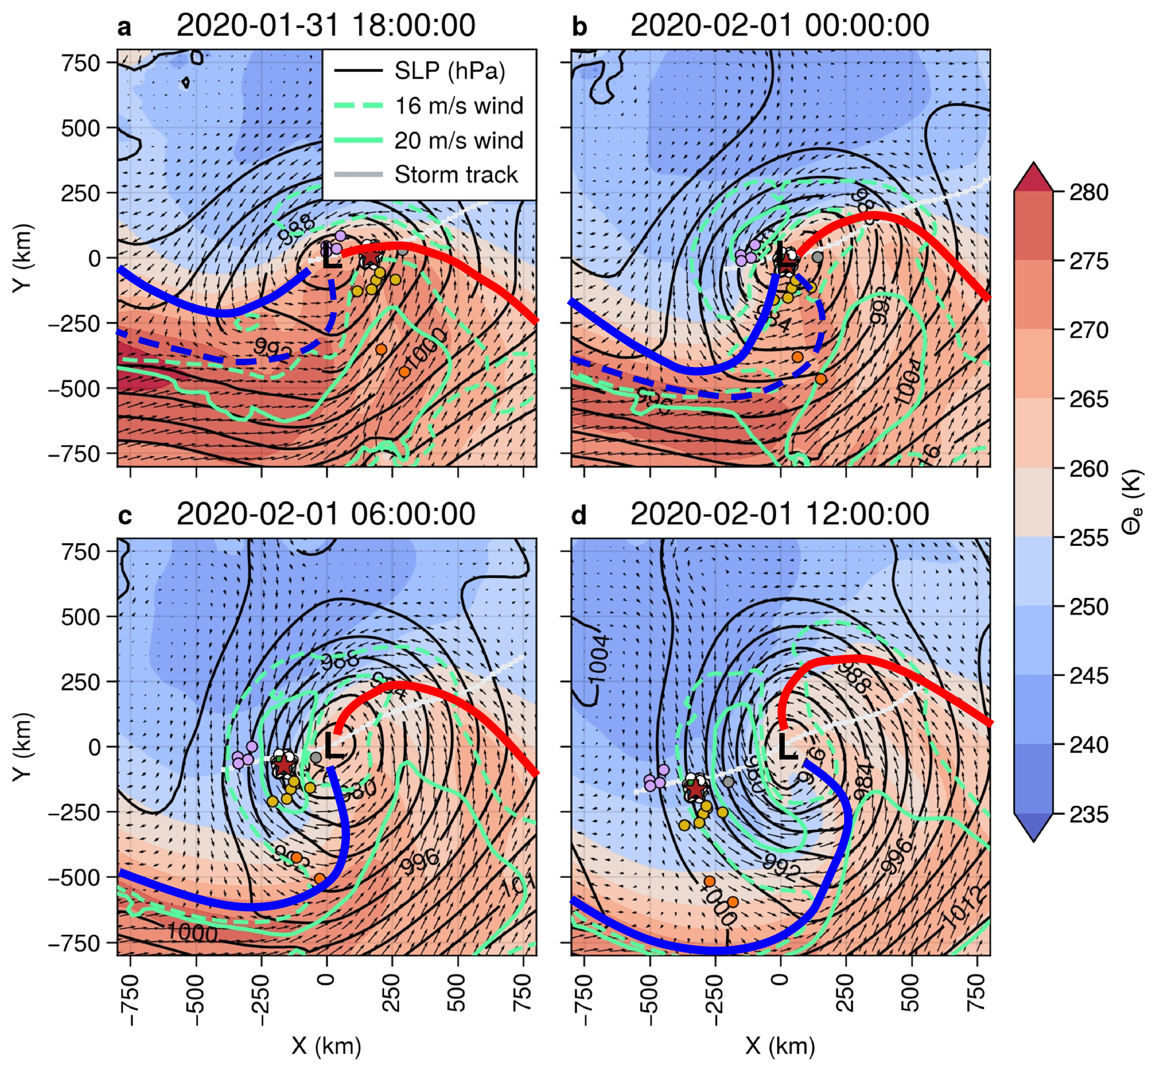

**Figure 3**. ERA5 reanalyses centered on the SLP minimum. Shown are SLP (hPa; black isopleths), 925 hPa equivalent potential temperature $θ_{e}$ (K; colors), 10 m wind vectors, select 925 hPa isotachs (16 and 20 m/s; green). Every other wind vector is plotted for clarity. The heavy red and blue lines show respectively the positions of the warm and cold fronts. Dashed fronts are thermal features aloft, while the solid fronts are surface-based. The light gray line shows the track of the low center within the domain, while the colored circles buoy positions. Colors for DN and Ex DN sites are as in Figure 1.

Utilizing the near-surface observations at the three ASFS sites and at the CO, rough observational surface analyses are possible on the ~50 km scale of the DN. Figure 4 shows isotherm analyses centered on the CO between 31 January 14:05 UTC, just prior to the passage of the surface warm front, and 1 February 06:41 UTC, nearly 5 hours after the passage of the surface cold front. These are overlaid on a low-elevation radar-reflectivity PPI scan from the scanning Ka-band radar to provide some indication of the spatial distribution and structure of the clouds and precipitation.

Moderate (5-10 m/s) southeasterly surface winds were present throughout the domain as the air temperatures warmed with the approaching surface warm front (Figure 4b). Within the warm sector, temperatures gradually warmed to -12 °C. Winds were initially moderate from the SSW but decreased in magnitude as the CO neared the low-pressure center, particularly after the cold-front aloft passed overhead. The more cellular nature of the clouds and precipitation after the cold front aloft passed can be seen in comparing Figure 4c and 4d. The trailing surface cold front entered the DN from the NW, marked by a sudden wind shift to the N and a trailing, very strong temperature gradient (Figure 4e-g). Air temperatures dropped to between -27 °C and -30 °C. The cold front took about 1.5 h to traverse the L-site triangle. The northerly winds increased throughout this frontal zone, reaching near-surface speeds of 12-15 m/s as the LLJ behind the front passed overhead (Figure 4 panels h-i). High wind speeds combined with strong cold-air advection leads to strong mixing near the surface, producing what appears to be horizontal roll vortices in the atmospheric boundary layer (suggested by the linear, along-wind, cloud features). Horizontal roll vortices are an effective mechanism for vertical mixing in the atmospheric boundary layer (Etling and Brown, 1993; LeMone, 1973).

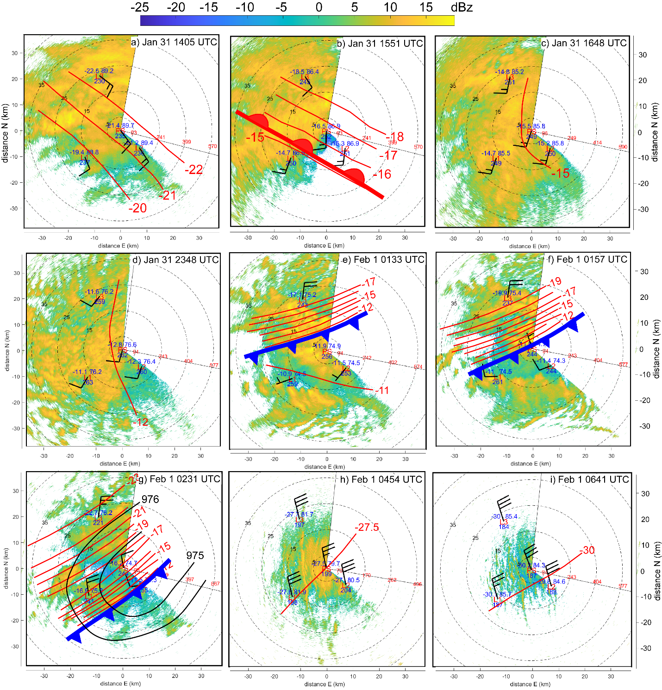

**Figure 4**. Near-surface meteorological observations of air temperature (°C), SLP (hPa), downwelling longwave radiation (W/m2) and wind barbs from the three L-site ASFSs (3.8 m) and at Met City (6 m) ) during the warm-frontal (heavy red, lobed line) passage on 31 January (a-b), cold frontal (heavy blue toothed line) passage on 1 February (e-g), and in the post-cold-frontal sector (h-i). Manual analysis of air temperature is shown in red lines with 1°C separation interval. Panels with only one isotherm represent times when the sptial temperature difference between sites is less than 1°C. Isobar analysis is depicted with black lines in panel g. The background shows the low-elevation scanning Ka-band radar reflectivity (color, dBz). Range rings show distance in kilometers (black) and radar-beam height above local surface (red, m). The thin black radii bracket the region not scanned by the radar. North is upwards for each panel.

The time-height sections of serial rawinsondes and near-surface time series of various parameters (Figure 5) confirm the features passing over the MOSAiC domain discussed above. The passage of the first low (C1) and its associated narrow warm-sector are clearly seen, with the brief but distinct warm air peak in the warm sector, and the cooling and veering of the surface wind with the passage of the cold front. A LLJ is present at approximately 250 m above the surface near the time of the warm-frontal passage and extending into the warm sector ahead of the cold front. The second cyclone (C2) is deeper with a broader warm sector over the CO. The air only warms slightly in the warm sector between the warm front and the cold front, but the thermal wind effect of this thermal gradient, with the warmest air closest to the cold front, is the likely cause for the observed LLJ within the warm sector at 250-300 m height. The rawinsondes show the warm-sector LLJ wind speed maximum near 15 m/s just above the surface mixed layer (SML), with associated near-surface wind speeds of 7-8 m/s (see also Figure 4c).

The passage of the cold front with the second cyclone near 02 UTC on 1 February marks the time of the lowest observed central pressure (974 hPa), a very sharp drop in surface temperature (-11°C to -38°C in only 12 h), a minimum in surface winds, and a rapid change in surface wind direction (see also Figure 4e-g). A second LLJ is observed at ~350-400 m height just behind the cold front with a core speed of 21-22 m/s, with again a deeper SML as indicated by the constant $θ_{v}$ with height. Just after the cold-frontal passage, the near-surface wind speed increases with the arrival of the LLJ above, reaching speeds of 14-16 m/s across the four observational sites between 04 and 05 UTC on 1 February (see also Figure 4h-i). The timing differences in the wind direction shifts and wind speed increases (Figure 5d-e) and temperature decreases between sites represent the progression of the cold front across the DN from the northwest. Stability differences in the sub-jet layers may cause the higher surface wind speed relative to its core strength for this second post-cold-frontal LLJ when compared to the warm-sector LLJ. A peak in the observed covariance surface stress at Met City (Figure 5f) occurs just after the cold frontal passage, and is coincident with the deepening of the SML just below the LLJ (Figure 5a) and the appearance of the likely horizontal roll vortices (Figure 4i). It is unclear whether enhanced turbulence caused by the LLJ or the apparent roll vortices have deepened the SML, or if the deeper SML has weakened the near-surface winds thereby producing a LLJ just above the SML. All of these features indicate significant, efficient, vertical momentum transport at this time.

The presence of the LLJ behind the cold front is likely due to the LLJ being quasi-axisymmetric around this second low. That is, it is a “wrap-around” LLJ that is likely an extension of the LLJ observed in the warm sector as this warm air wraps around the strong but compact cyclone center, as seen in Figure 3. Note that there is not much of the warm air remaining with this wrap-around LLJ, and that it is at a slightly higher altitude, consistent with some lifting as the LLJ has wrapped itself around the cyclone center. The 6-h soundings do suggest a thermal wind contribution over a ~100 m deep layer at the core of this second LLJ; it is beyond the scope of this paper to examine whether this brief reversal in horizontal temperature gradient is sufficient to fully support this LLJ structure. We infer that the presence of two LLJs in fairly rapid succession, or alternatively, a wrap-around LLJ within a rapidly moving storm system, produces strong, rapid surface wind speed and wind direction changes as the cyclone translates across the MOSAiC domain, and is key for forcing the significant ice motion, ice deformation and upper-ocean current changes observed during the passage of the second cyclone. This double LLJ (wrap-around LLJ) was observed in other MOSAiC cyclones with significant ice deformation (not shown).

Low-level atmospheric divergence is one way to quantify these wind transitions. Indeed, we observe significant atmospheric convergence with the passage of the warm and cold fronts of low C2, with the strongest convergence (~30 x 10-5 s-1) occurring with the cold-frontal passage (Figure 5g). Ice convergence and shearing show significant peaks in association with this atmospheric convergence near the cold front. There is no appreciable ice divergence/ convergence within the L-site triangle with the warm frontal passage, though there is significant shearing of the ice. Note that other wind transition events for which wind speeds are appreciable also show some atmospheric divergence/convergence and some ice deformation (e.g., near 08 UTC on 3 February, also associated with a LLJ). Nevertheless, ice deformation events can have multiple local and nonlocal causes, and therefore often are not associated with local atmospheric divergence.

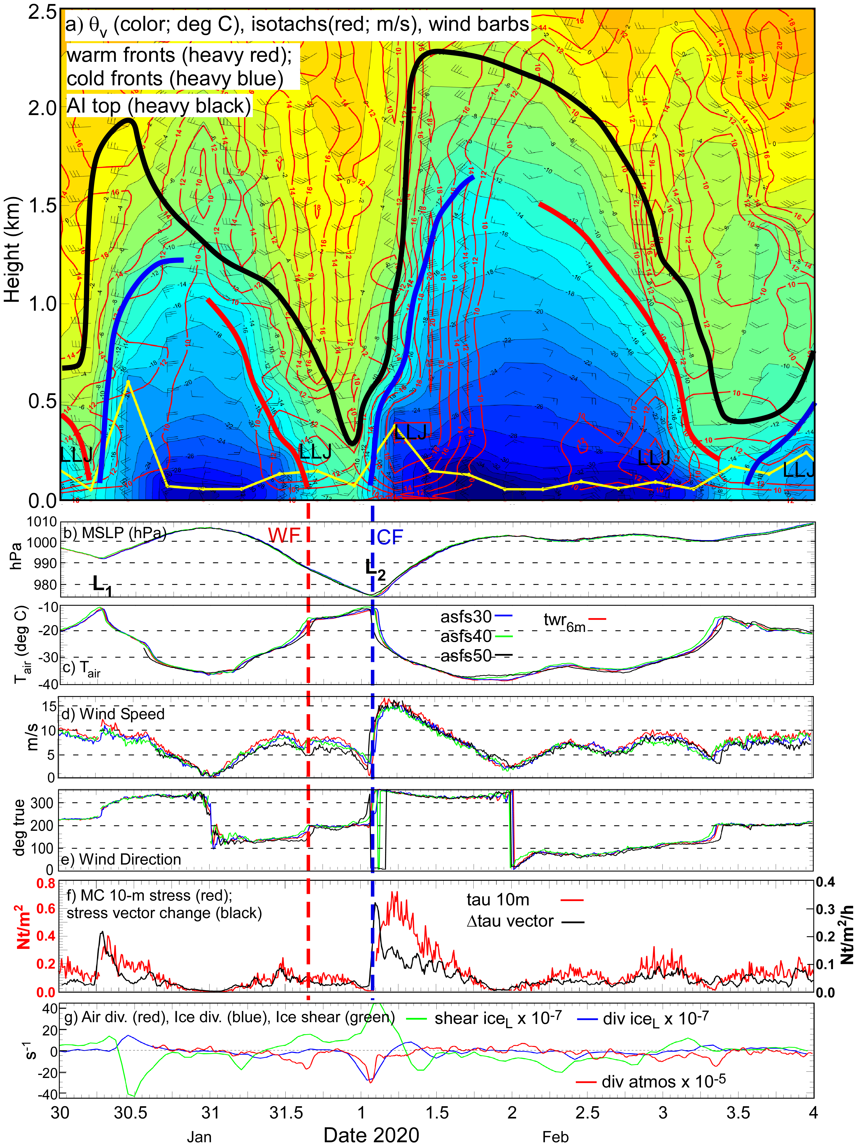

**Figure 5**. a) Time-height section of virtual potential temperature ( $θ_{v}$ colors), isotachs (red), and select wind barbs from serial rawinsondes at the R/V Polarstern. Heavy (red, blue, black) lines mark warm and cold fronts and the top of the Arctic inversion (base of the free troposphere), respectively. The thin yellow line marks the top of the surface mixed-layer. Low-level jets (LLJ) are also marked. Rawinsondes were launched every 6 hours, launch times indicated by the origin of the wind barbs. Lower 6 panels: Time-series from the Met City tower and the ASFG of b) SLP; c) Ta; d) 10-m and 4-m wind speed; e) 10-m and 4-m wind direction; f) 10-m atmospheric stress (red), stress vector change (black) at MC; and g) 4-m atmospheric divergence (red), ice divergence (blue), and ice shear (green). The vertical dashed lines show the times when the warm (red) and cold (blue) fronts with the second cyclone pass over.

4 Sea ice dynamics

4.1 Atmosphere-ice interaction

Sea ice motion at during the passage of the storms is broadly coherent with time-varying wind forcing. The drift speed ratio $α$ (the ratio between the drift speed and the wind speed) and net turning angle $θ$ (the difference between the wind direction and the drift direction) vary significantly over time (Figure 6, bottom panels e and f). These parameters are empirical measures of the relationship between the ice drift and the wind speed. In steady state free drift $θ$ is a function of the boundary layer structure and the ice surface roughness, and $α$ is a function of the air-ice and ice-ocean drag coefficients and the densities of each medium. For the period shown in Figure 6e-f, average values of $α$ and $θ$ are 0.021 and 35, respectively, consistent with previous studies (Leppäranta, 2007; Schweiger and Zhang, 2015; Womack et al., 2022). Drift speed ratio increases after 1 February, which can indicate that a larger fraction of atmospheric momentum is being translated into ice motion rather than adding to the internal ice stresses. Increases in $α$ following cyclone passage has been observed previously (e.g., Itkin et al., 2017). The drift speed ratio following the second cyclone passage oscillates near the inertial frequency (~12 hours), suggesting the possibility of inertial oscillations following the storm.

Drift trajectories of the three L-sites and the CO (Figure 6a-d) generally illustrate the expected right hand turning rule ( $θ>0)$ first noted by Nansen (1902). At all four sites, the ice drift arcs to the right and slows as the 29 January cyclone moves away from the MOSAiC site. At the pressure ridge between C1 and C2, the wind direction abruptly reverses. This reversal occurs at 23 UTC on 30 January at all sites, marked by the red letter A. As SLP decreases and C2 approaches the CO, the ice drifts northward until slowing to a halt and again reversing direction. The cusp in the trajectory marking the reversal is indicated by the letter B. Notably, this reversal preceeds a rapid acceleration, and occurs at different times at each site: first at 22:30 UTC on 31 January at L3, next at 0 UTC on 1 February at sites L1 and at the CO, and last at 0:30 UTC on 1 February at L2. Cusps in DN buoy trajectories can be identified by local minima in drift speed. Cusp timestamps display a west-east gradient spanning a 3-hour period consistent with ~25 km/h cyclone propagation speed (Figure 7b), with some deviations due to internal ice stresses propagating nonlocal forcing. Further from the storm center, 48-hour drift trajectories show clockwise motion to the right of the storm (Figure 7c, d) and counter-clockwise motion to the left (Figure 7a), with the sharpness of the turn increasing toward the storm center.

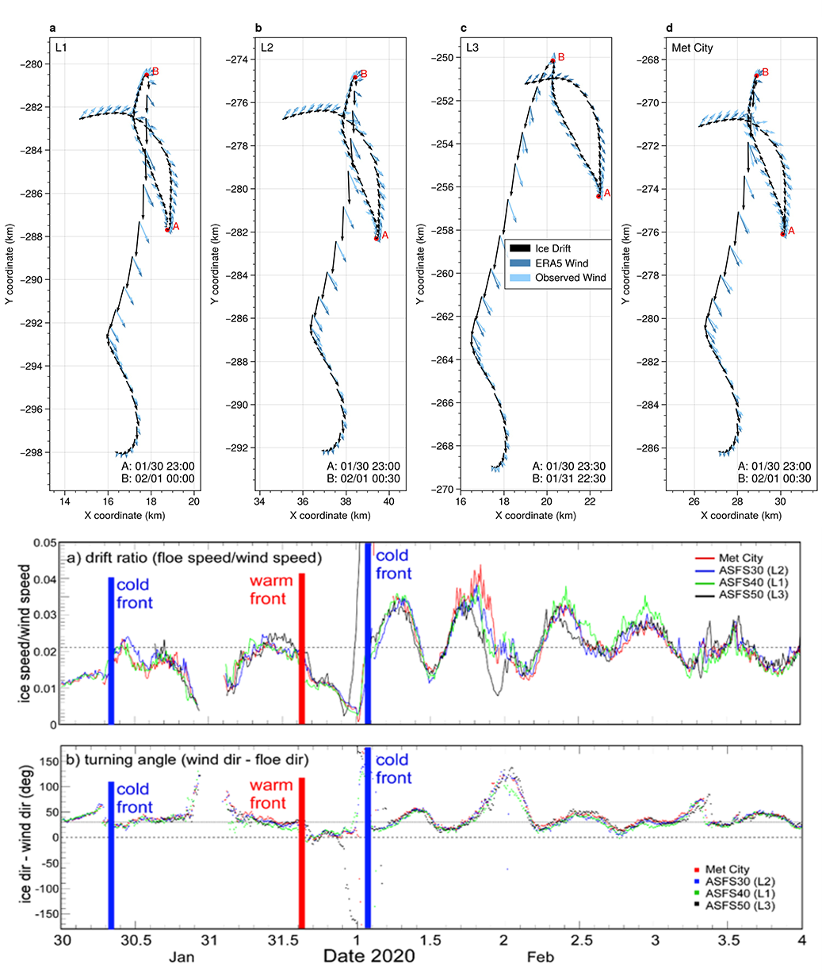

Figure 6. Top a-d: Trajectories of sites L1, L2, L3, and Met City at hourly resolution from 30 January 00:00 UTC on 02 February 00:00 UTC. Black arrows indicate the ice drift direction, light blue the observed wind direction, and dark blue the estimated wind from the ERA5 reanalysis. Arrow length is proportional to velocity. Bottom: (e) Drift speed ratio (ice speed divided by wind speed) and (f) empirical turning angle (difference between wind direction and ice drift direction) derived from 10-min observations at sites L1, L2, L3, and Met City.

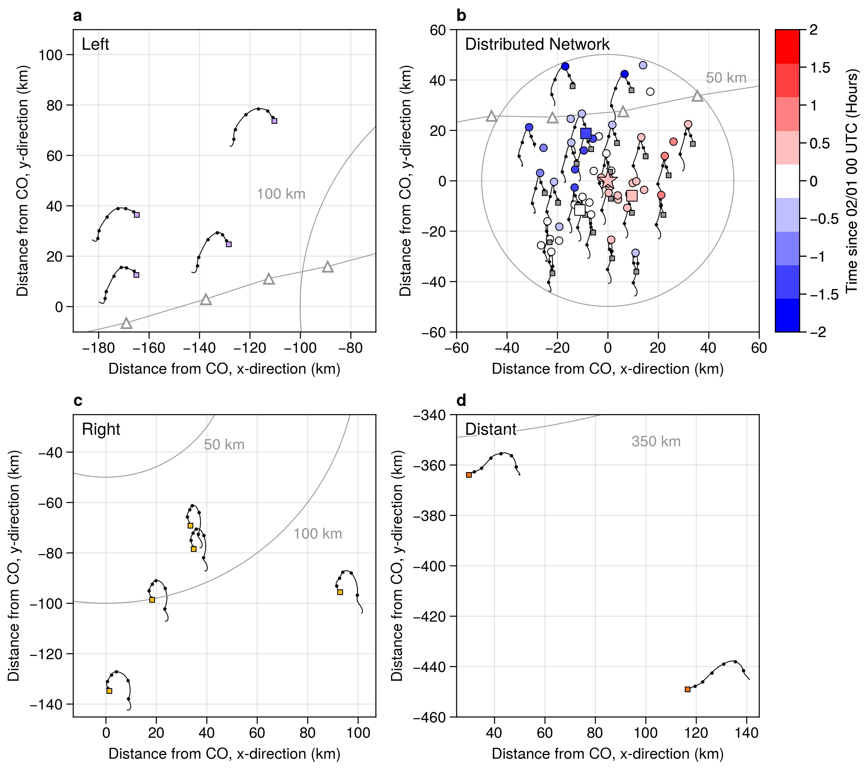

**Figure 7**. Buoy trajectories from 31 January 00:00 UTC to 2 February 00:00 UTC. Small squares indicate the beginning of the time series. Black lines show the 30-min resolution drift tracks, and black circles show the position every 6 hours. Distance from the CO is indicated with the axis units and radii at 50 km, 100 km, and 400 km. In panel b, the time of the drift speed minimum relative to 1 February 00:00 UTC is indicated with color. Trajectories of a subset of DN buoys are shown for clarity. L-sites are marked with large squares, while the CO is marked by a star. In panels a and b, the position of the sea level pressure low from the ERA5 reanalysis is marked at hourly intervals with white and gray triangles.

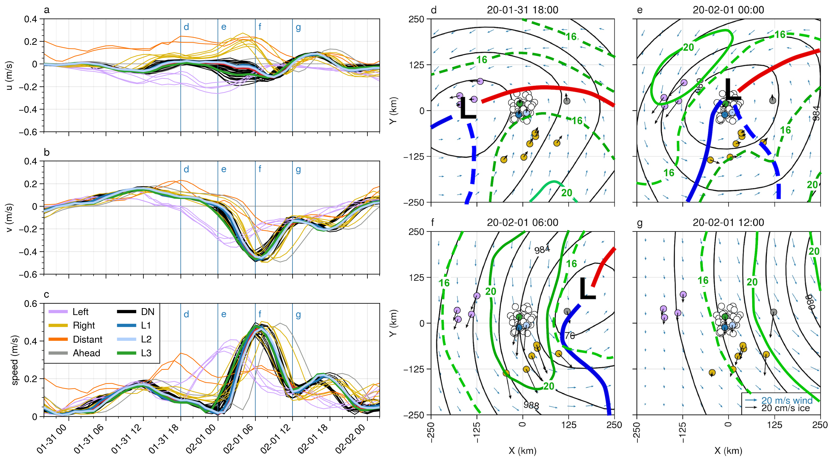

**Figure 8**. Left: Buoy velocity components (a, b) and magnitude (c) for the period from 30 January 20:00 UTC to 2 February 02:00 UTC. The top and middle panels show the u and v velocity components relative to the north polar stereographic projection, thus corresponding to the x and y axis, respectively, in the panels on the right. For the period shown here, the positive y direction is approximately northward. Right: Snapshots of buoy motion (thick black arrows) superimposed on the ERA5 sea level pressure isobars (black contours, 4 hPa spacing), near-surface (10 m) wind fields (blue arrows), and 16 and 20 m/s isotachs of the 950 hPa winds (green contours) at times corresponding to vertical lines in the velocity time series to the left. The position of the SLP minimum is marked with “L”. The cold front is marked in blue and the warm front marked in red, solid fronts are surface level and dashed are elevated.

The clearest sign of the storm’s impact on the ice velocity is through the effect of the LLJ as it develops and moves across the MOSAiC array. High ice drift speeds indicate efficient downward mixing of momentum through the surface layer. Since buoy velocities were not assimilated in ERA5, coincident ice velocity and 950 hPa wind speed maxima (Figure 8d-g) serve as an independent confirmation that the location of the LLJ in ERA5 is approximately correct. The C2 cold sector LLJ first passes over the left buoy group, where drift speeds reach an average speed of 37 cm/s between 01:00 and 02:00 UTC on 1 February. The DN buoys come nearly to a full stop before reversing direction and being accelerated by the cold sector LLJ, and there is a larger spread in velocity between the DN buoys during this time, implying deformation. Maximum speeds of 42-49 cm/s occur between 05:00 and 08:00 UTC on 1 February as the LLJ passes overhead. The DN buoys and the right group reach their maximum speeds at approximately the same time (Figure 8c, f) yet due to the difference in distances in the radial direction the direction of motion is different.

4.2 Sea ice deformation

Differential buoy motion across the buoy array implies deformation. We measure this deformation by monitoring the changes in polygons formed by subsets of the buoy array (Figures 9, 10) and through examination of ice radar imagery (Figure 11). At moderate-to-large scales (purple, yellow, and black lines in Figure 9), the largest signals in strain rates can be understood as responses to the cyclone-scale wind gradients and the positions of the LLJs. As a band of high wind speeds is advected over the ice, the ice experiences changes in vorticity, divergence, and shear strain rate (Haller et al., 2014; Lindsay, 2002). For the LLJ behind the storm, the vorticity pattern is first cyclonic, accompanied by gradually increasing divergence (opening), then as the wind speed slows, the sense of rotation reverses, and the ice closes. Significant variability exists in the strain rates, particularly maximum shear strain rate, likely due to the complex interaction of the geometry of ice fractures and the varying wind forcing. The vorticity signal is broadly coherent (Figures 9c, 10c), with a clear peak in positive vorticity at 2-3 UTC on 1 February and a trough of strongly negative vorticity between 9-11 UTC on 1 February. This coherent positive ice-vorticity signal should be expected from the presence of the narrow axisymmetric atmospheric LLJ surrounding the cyclone. The positive vorticity signal as the storm approaches is damped because the LLJs developing in the warm and cold sectors of the storm had not yet joined; the winds ahead of the low center were weaker than the winds behind it (cf. Figure 3).

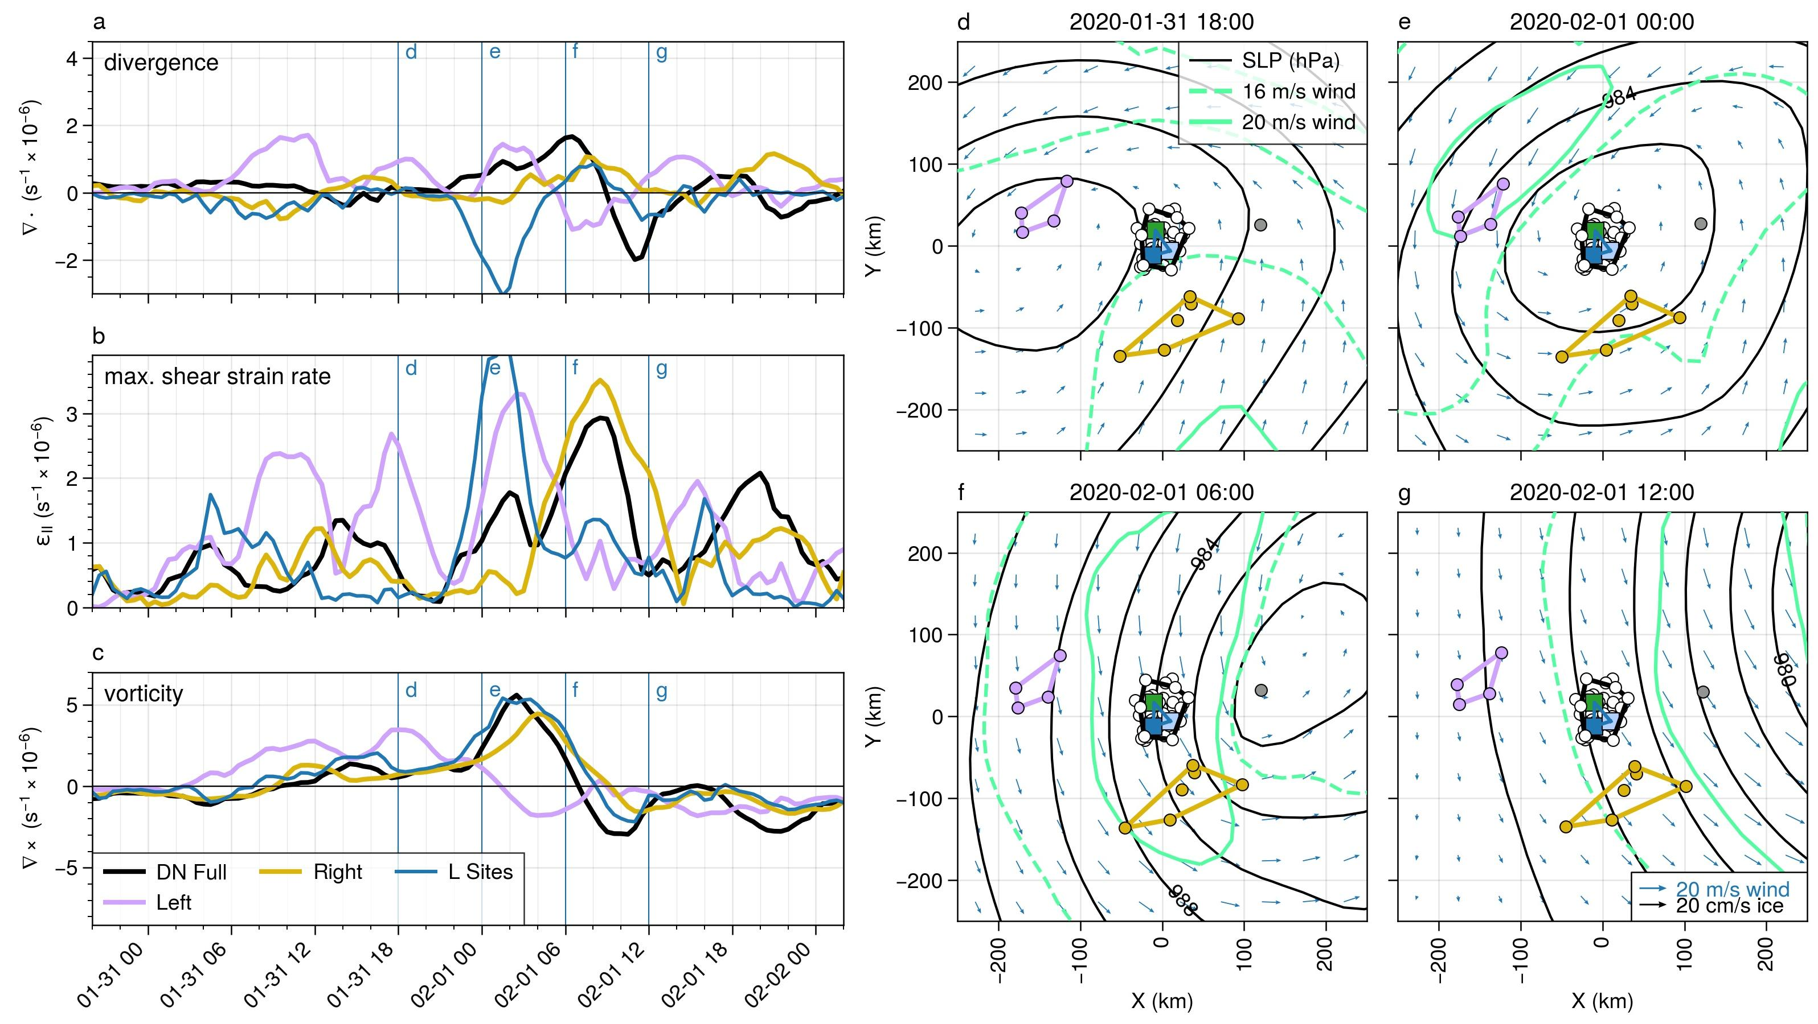

**Figure 9**. Strain rate components (a-c) and velocity anomalies (d-g) of the Distributed Network and Extended DN for the February 1 cyclone. Polygons used for the deformation calculations are shown in panels d-g. Polygons were selected manually. Length scales are 57 km, 40 km, and 66 km for the DN Full, Left (purple), and Right (yellow) arrays, respectively, and 18 km for the L-site array (blue).

Within the DN, the small-scale polygons generally follow the pattern of the DN, with initial positive divergence as the LLJ enters the scene. The importance of local structure of fracture networks for floe-floe interactions is demonstrated in the broad range of divergence values, and in the outlying tendency of the L-site triangle. Considering the wind field shown in Figure 9d-g and 10d-g, and the tendency of ice to move to the right of the wind, we expect opening (positive divergence) while the low is centered over the DN. In pack ice, individual floe motion is limited by interaction with neighboring floes, leading to “multifloe” (~2-10 km) and “aggregate” (10-75 km) motions in the hierarchy proposed by McNutt and Overland (2003). The buoy velocity anomalies show that a region of at least 20 by 60 km is moving approximately coherently within the DN (Figure 10d-g). As the wind direction changes, the geometry of the interlocked floes results in different regions moving as aggregates. The passage of the low-level jet, as indicated by the rise and fall of sea ice velocity, occurs within approximately 12 hours. Differences in the ice motion due to the storm structure are visible at ~100 km length scales, while significant deformation is occuring at ~10 km length scales. Thus, the strongest impact of the storm on the ice velocity and deformation is occurring at time and space scales shorter and smaller than typical remote sensing ice motion observations and model resolutions.

With full ice cover, there is considerable resistance to ice opening. As the winds recede, the newly opened leads offer little resistance, so the convergence across the set of polygons is faster and more cohesive. The position of shear zones can lead to errors in area-average strain rates, as discussed in (Lindsay, 2002; see also Thorndike, 1986). In the case of a diagonal crack crossing a square polygon, shear along the crack will result in a measurement of opening or closing. Considering the deformation of the L-site triangle, the anamolous convergence shown in Figure 9a and 10a is likely an artifact of the triangle orientation relative to a shear zone. The presence of this shear zone is clearly visibile in the velocity anomaly map of Figure 10e. Higher confidence can be placed in the estimate of deformation from the DN Full array due to the larger number of buoys used. Over the 10-day period from 26 January 2020 to 5 February 2020, the area of the “DN Full” polygon changed from 3.17km2 to 3.21km2, a change of just over 1%. Rapid area increase (i.e., positive divergence) occurred on 1 February due to the passage of the cold sector low-level jet, such that the area of the polygon increased by 3.5% in a 9-hour period. Given that the surface air temperature was -10 °C or below during this period, any leads would have quickly begun freezing over; the net increase of area over the 10-day period is an indicator of thermodynamic ice growth and mechanical redistribution of ice thickness.

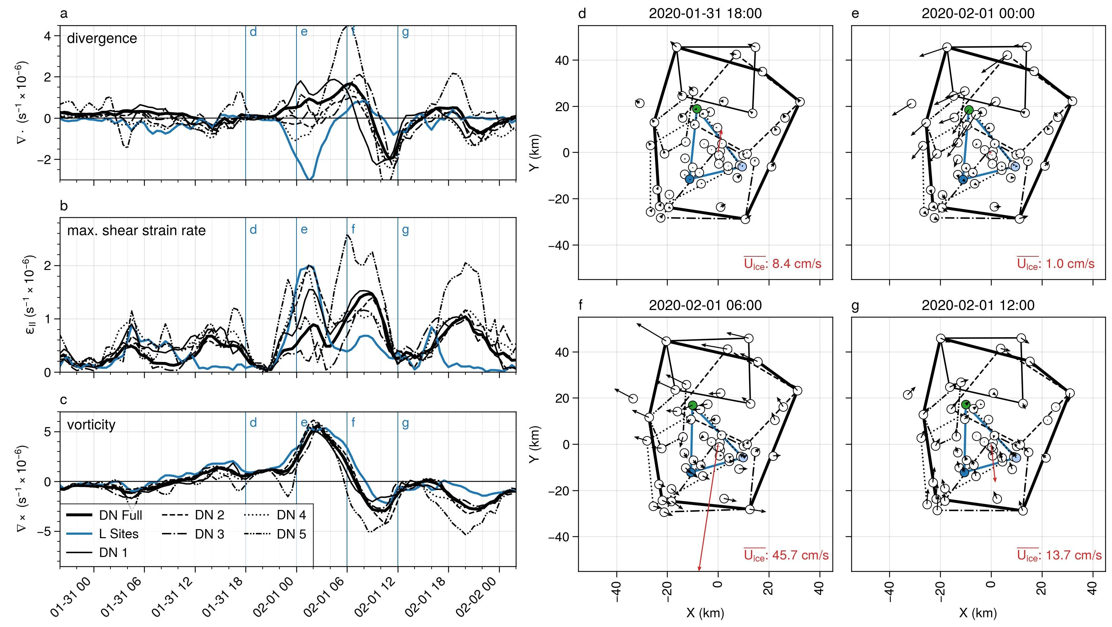

**Figure 10**. Strain rate components (a-c) and velocity anomalies (d-g) of the Distributed Network for the February 1 cyclone. Polygons used for the deformation calculations are shown in panels d-g. The polygons were selected manually; note that the buoy in the upper left was not included in the “DN Full” array due to periods of missing data. Velocity anomalies in panels d-g were computed relative to the ensemble average velocity, which is shown as the red arrow at the center of each panel. The length scales of the polygons (square root of the average polygon area) are 28, 33, 28, 30, and 15 km for DN sub-arrays 1-5 respectively, 18 km for the L-site triangle, and 57 km for the “DN Full” array.

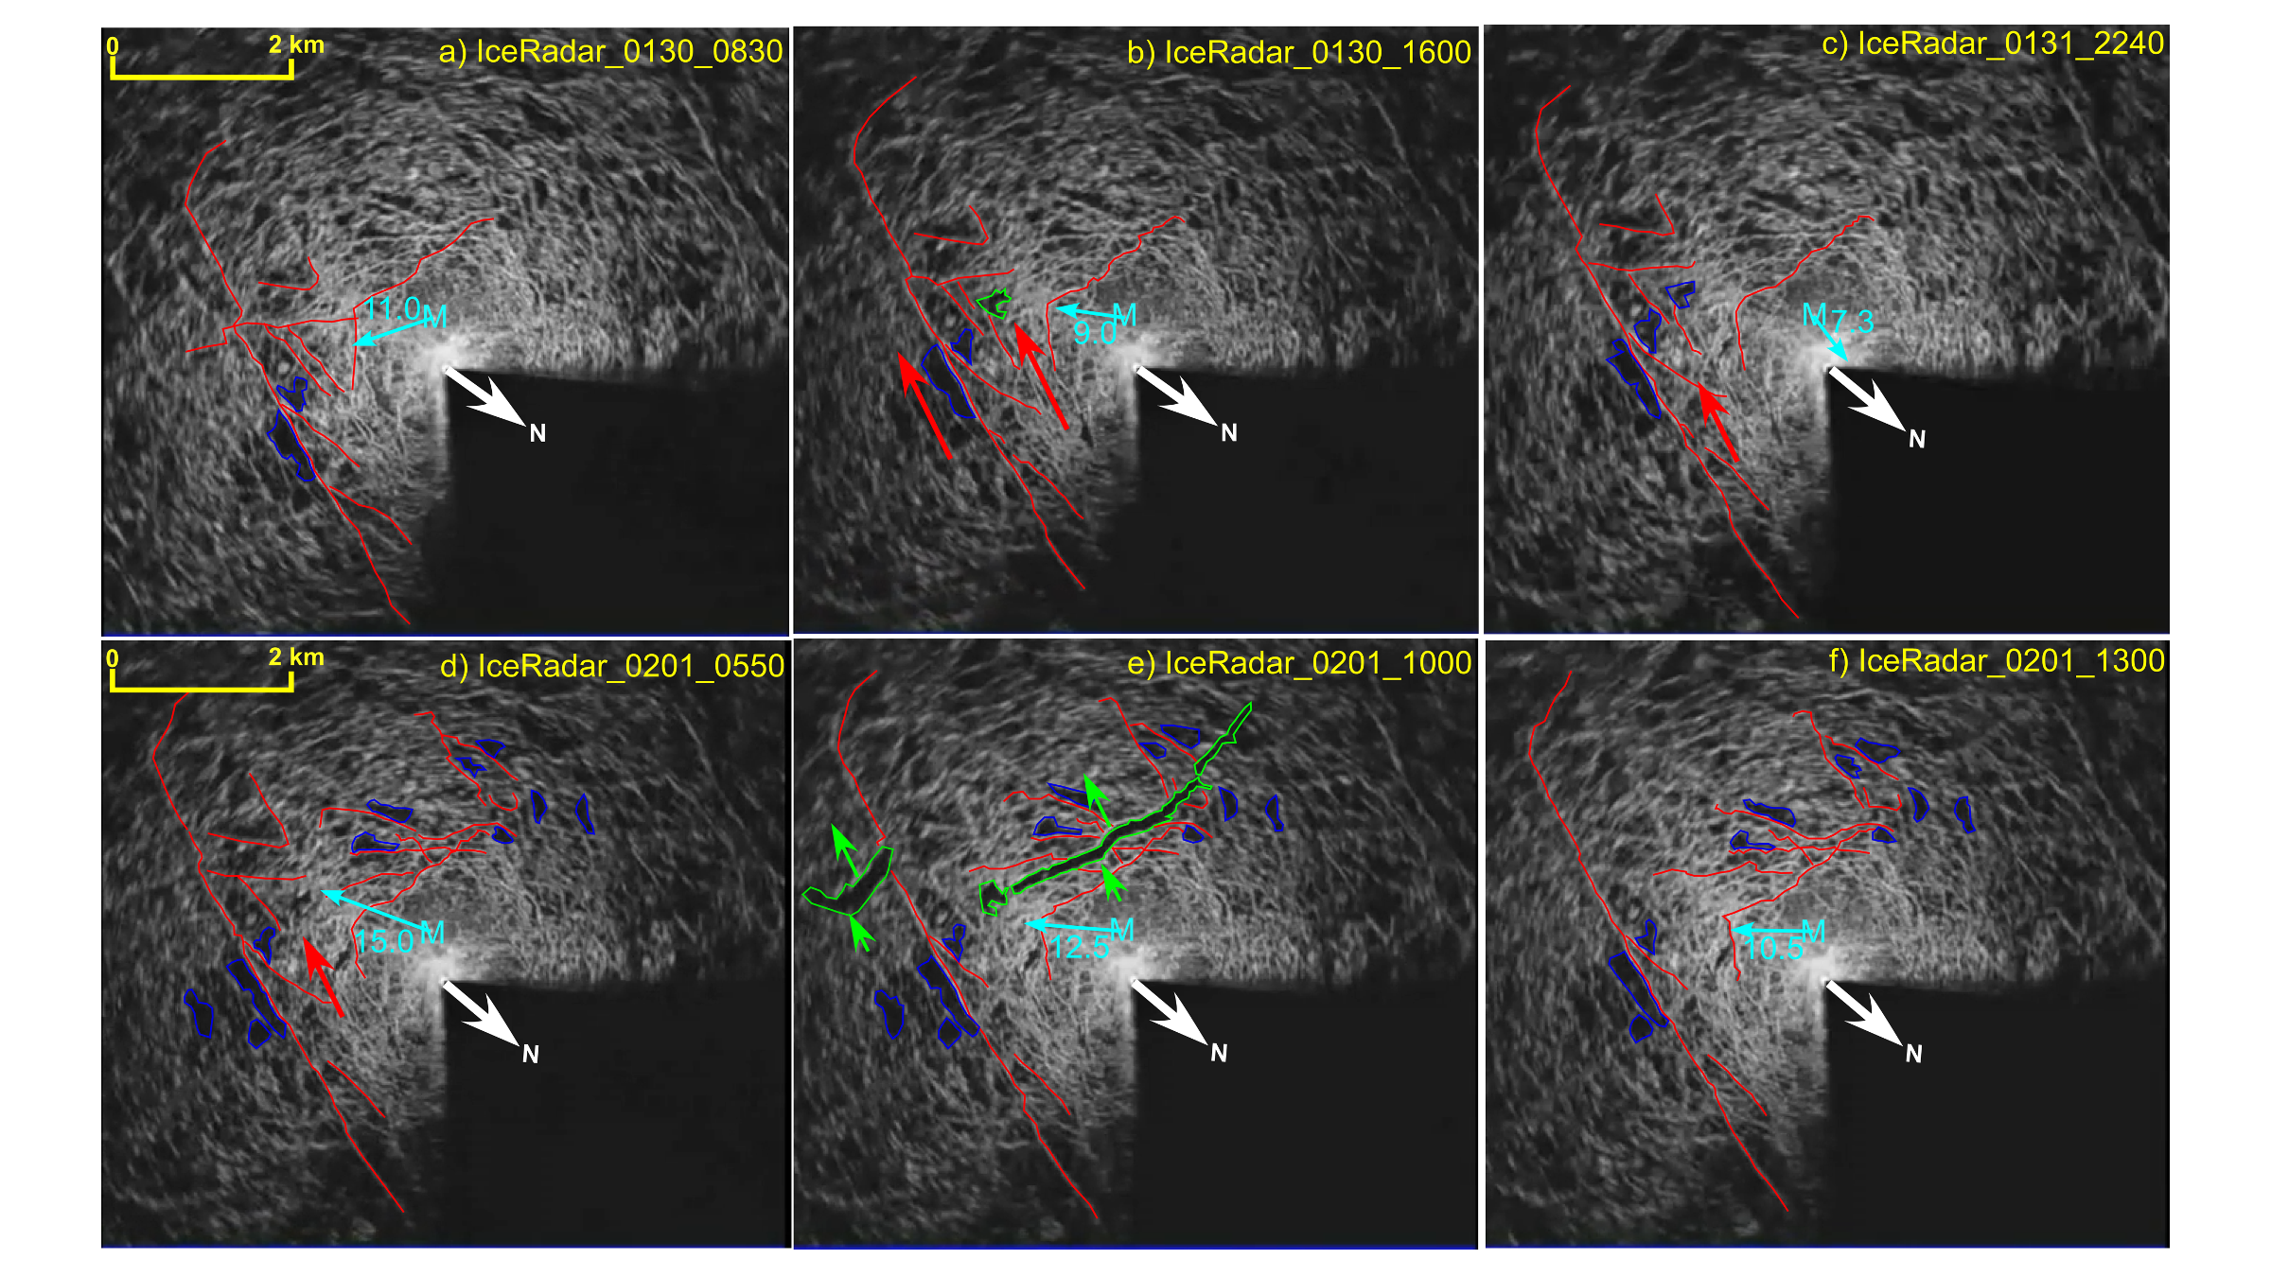

**Figure 11**. Backscatter from the ice radar on board the R/V Polarstern showing the establishment of an ice shear zone to the east and south of the ship. Images are at (a) 30 January 08:30 UTC b) 30 January 16:00, c) 31 January 22:40 UTC d) 1 February 05:50 UTC, e) 1 February 10:00 UTC, and f) 1 February 13:00 UTC. Red lines (blue polygons) mark areas of enhanced (suppressed) backscatter that are present in one image to the next. The green polygon shows regions of suppressed backscatter that appeared since the previous frame, the red arrows show the relative motion for that portion of the ice. The cyan number and arrow show the wind speed and direction at 10-m height from the Met City tower (M). The dark sector is blocked from the radar by the ship superstructure.

The ice radar images provide details of the ice deformation near the CO. Figure 10 depicts radar backscattering signal strength which is related to sea ice roughness features around the MOSAiC Central Observatory. Dark areas in radar images are interpretated as undeformed level ice or leads. Bright backscattering arises from ridges and edges of leads. Changes in images are directly related to relative displacement of sea ice objects from the *R/V Polarstern* or formation of new leads and ridges. The first pair of images illustrates the shearing that occurred between 08:30 and 16:00 UTC on 30 January, establishing a shear zone near the CO that then activated again between 22:00 UTC on 31 January and 00:00 UTC on 1 February. This latter time period of shearing motion corresponds to the peak in shear near 23 UTC on 31 January in Figure 10b. The red arrows in Figure 11b mark the section of ice that moves upward and to the left on the left side of the *Polarstern*, actually opening a small lead area (green). The relative movement can be seen by comparing the relative positions of the highlighted common backscatter regions in each panel. This region of ice again moves upward a little in Figure 11c. The ice divergence maximum occurring near 06 UTC on 1 February in Figure 11a is also apparent in the ice radar data in Figure 10 between 05:50 UTC and 10:00 UTC on 1 February, two leads 100-200 m across and 1-4 km long open up about 2 km downwind of the *R/V Polarstern* (green areas in Figure 11), indicating ice divergence. Note that this time period also corresponds to the period of large atmospheric stress (Figure 5f) and the atmospheric horizontal roll vortices (Figure 4h-i). However, over the course of the next 3 hours, these leads appear to close, indicating ice convergence. Note that Figure 10a shows ice convergence occurring between 09:00 UTC and 13:00 UTC on 1 February, in excellent agreement with the ice radar observations.

5 Upper ocean response to sea ice motion

Comparisons between the wind, ice and earth-reference current speeds at 5, 20 and 60 m depths (Figure 11a) summarize the transfer of momentum from the atmosphere, to the ice, and then to the ocean. This timeseries is dominated by distinct wind events on 30 and 31 January, and the strong transient event early on 1 February (Figure 11a; see also Figure 5). Each wind event accelerates the ice, which in turn accelerates the ocean layer below the ice as the turbulent ocean Ekman boundary layer forms. This can most clearly be seen in the 1 February event with wind magnitude dropping to near zero, within the annulus of the atmospheric LLJ, followed by an increase to 16 m/sin the following few hours. A local maximum ice velocity of 0.5 m/slags the wind speed peak by 3 hours, while a 0.27 m/scurrent speed maximum at 8m depth lags the ice speed maximum by ~1 hour compared to ~2 hours at 20m depth. These temporal lags are a result of the inertia of first the surface wind stress accelerating the ice, and then the depth-dependent acceleration of the upper ocean as the ice-ocean turbulent boundary layer forms in response to changes in direction and magnitude of the ice motion.

Rapid changes in ice speed and direction during this event also force significant levels of circular inertial motion in the coupled ice-ocean system. This can be seen in the dampened oscillatory current components in the north-south and east-west velocity timeseries in Figures 12c and 12d, starting near 1 February at 06 UTC on with the inertial ringing decaying over the following two days. The observed ocean currents represent a superposition of inertial ringing and the evolving boundary layer currents forced by the 02 UTC wind event on 1 February and subsequent smaller wind maxima at 12 UTC on 2 February and 00 UTC on 3 February. The inertial ringing is a resonant response to the combination of sharp transient lateral accelerations of the ice/upper ocean coupled with the orthogonal Coriolis acceleration. They are widely observed in the Arctic, with higher magnitudes seen in high open water fraction conditions where ice mobility is enhanced (for example, Brenner et al., 2023). For this event, the 5 m depth east-west currents track the ice motion very closely (Figure 11a) with a small phase lag and reduced current component magnitude at 20 m, while the north-south component shows an inertial response from the ice down to at least 20 m but with a larger mean boundary layer current superimposed during 1 February. As expected, there is little direct coupling of this inertial motion below the seasonal ~40 m deep mixed layer at the 60 m depth time series, as the strong density jump at the base of the seasonal mixed layer greatly reduces mixing and hence momentum transfer to greater depths.

Comparison between atmospheric surface stress and 4 m ocean stress during this period (Figure 12e) shows a deficit on the ocean side of the ice. There are two primary reasons for this difference, which will be explored in detail in a subsequent publication. The first is the ability of the ice pack to remove surface-imposed momentum through a combination of internal ice stresses and ice deformation. The second is the important role of form drag in the MOSAiC ice pack. The momentum transferred by ice keels and floe edge features is not captured by the friction velocity u* which arises from upstream, small scale roughness features across the ensemble of ice floes and generates the turbulent ocean boundary layer. Lags between the peaks of atmospheric stress and ocean stress, most clearly seen in the strong 1 February event, arises from the inertial lag of the ice pack to surface wind stress.

The vertical structure of upper currents in response to this wind event (Figure 12) illustrates the fairly complex interaction of the ice/ocean boundary layer with weakly stratified mesoscale ocean features within the seasonal mixed layer, which were seen during much of the MOSAiC transpolar drift. High temporal resolution vertical shear of the N/S current component sampled every 15 minutes by the AOFB current profiler at the CO (Figure 12c) provides some insight into the complex structure of the active mixing layer. Ideally, CTD profiles at a comparable temporal resolution would show the evolution of stratification within the mixed layer, which frequently contained weak mesoscale density structures limiting the depth of mixing during wind events. However, the much higher resolution shear profile time series in Figure 12c reveal both the development of strong near-surface shear as the sub-ice Ekman layer forms, and the development of regions of higher shear within the ~40m deep seasonal mixed layer. These shear layers indicate the lower extent of the mixing layer where even weak density gradients inhibit turbulent mixing deeper within the seasonal mixed layer. Measurements of these weak stratification layers are estimated from the depths where there is a density increase of 0.01 Kgm-3 from surface values for each CTD profile, and are plotted as filled red circles in Figure 12c. These sparse in time observations track with the layers of increased shear measured in the current profiles. The red mixed layer depth timeseries in the Figure 12 panels represent coarse interpolated estimates of the depth of the top of the halocline.

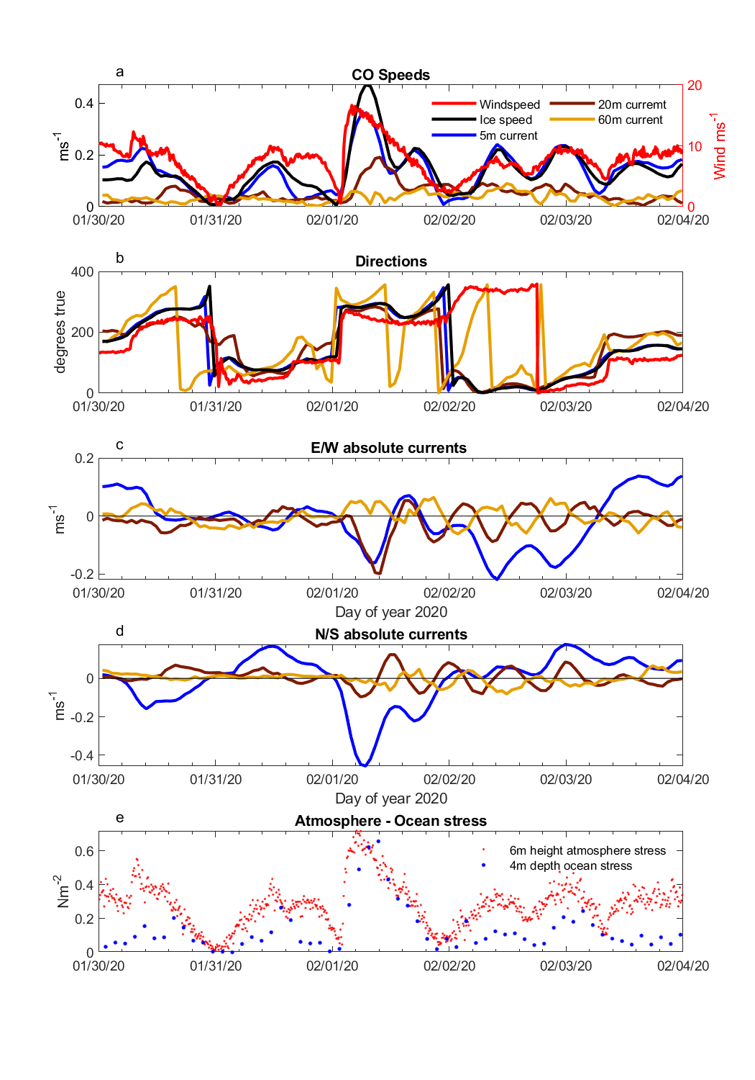

**Figure 11**. From top to bottom: (a) Timeseries of windspeed (red), ice speed (black), 5 m (blue) 20 m (green) and 60 m (orange) depth absolute current magnitude; (b) Corresponding current and wind directions in degrees true; (c) Timeseries of 5 m (blue), 20 m (brown) and 60 m (gold) north-south current components; d) east-west current components; e) 4 m depth ocean kinematic stress from the CO site Autonomous Ocean Flux Buoy (blue dots) and atmospheric stress (red dots) for this study period.

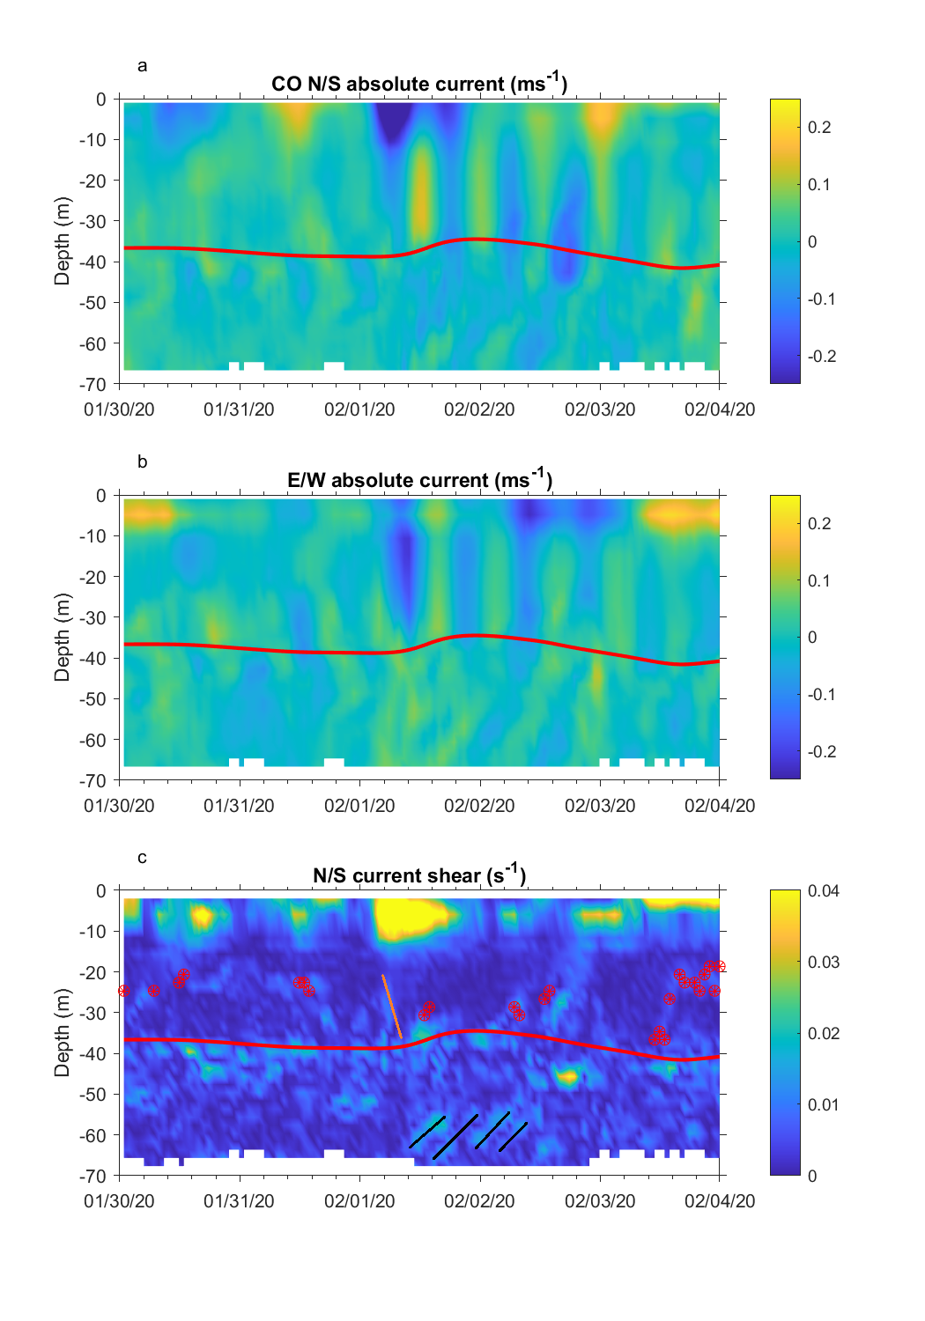

**Figure 12**. North-south current profile timeseries from the L1 site Autonomous Ocean Flux Buoy acoustic Doppler profiler. b) Corresponding East-West current component profiles. c) North/South current shear profiles with a clipped color scale to emphasize shear layers within the ocean mixed layer and upper part of the salinity-stratified pycnocline. Near surface shear reaches 0.07 s-1 during the 1 February wind event. The red timeseries represents an estimate of the depth of the top of the halocline. The sloping orange line highlights the rapid penetration of mixing in response to this wind event. The four black sloping lines identify shear associated with inertial internal waves within the strongly stratified pyncocline forced by the strong inertial motions within the ocean mixed layer.

The highest vertical shear levels of the north/south current component (Figure 12c) are seen in the upper 15 m during the strong 1 February wind event. However, active mixing extends down through the seasonal mixed layer to the halocline seen most clearly in the E/W current profile (Figure 12b) and the elimination of shear at the weak stratification interface between 20 m depth and the halocline (marked by the orange line in Figure 12 c). An example of reduced mixing depth by a mesoscale feature at the base of the mixed layer is seen starting at 12:00 UTC on 1 February despite the continued strong surface forcing. The CO drifts over another weak stratification feature that extends up from the pycnocline as winds reduce to 3 m/sat 00:00 UTC on 2 February. The interplay between surface mixing and these frequent mesoscale features with a wide range of density gradient strengths observed during the MOSAiC drift complicates a 1D view of wind-forced turbulent momentum transfer into the ocean. Analysis of these mesoscale features is beyond the scope of the present paper, and will be explored in subsequent publications.

Strong inertial-period motions in the ocean mixed layer are capable of generating internal inertial-period waves within the pycnocline after the mixing layer inertial currents contact the strongly salinity-stratified pycnocline. In the current component profiles (Figures 13a and 13b) this can be seen as slanted bands of enhanced current shear with inertial periods starting around 45 m depth after the 1 February wind event. These regions of enhanced shear are also shown as black slanting lines in Figure 12c. These inertial waves are an important source of shear that can induce mixing in the otherwise very quiescent and non-diffusive Arctic pycnocline.

6 Discussion and conclusions

We presented a detailed description of an observed strong mid-winter, central Arctic cyclone which passed over the MOSAiC observatory from 31 January to 1 February, producing changes in the structure of the atmospheric boundary layer, widespread sea ice deformation, and momentum flux into the upper ocean. The comprehensive suite of MOSAiC instruments together provide observations of the coupled air-ice-ocean system during an evolving cyclone with unprecedented detail and spatial resolution. Local sea ice trajectories are a function of the distance to the storm track and the orientation of the storm. The timing and location of sea ice deformation strongly depended on the stage of storm development and its spatial structure.

The development of a strong low level jet is a key feature of the cyclone, producing the strongest signal in the sea ice velocity. In this case, the jet ahead of the pressure low was not fully developed as the cyclone entered the observatory. The elevated surface wind speeds ahead of the storm produced an increase in drift speed and resulted in ice shear. The developed jet behind the cold front produced strong deformation in the ice, with divergence ahead of the jet and convergence behind. The rapid increase in sea ice velocity with the arrival of the jet produced a jump in the ice-ocean stress, initiating an inertial oscillation in the sea ice and upper ocean. The initiation of the inertial oscillation in the ocean extended the impacts of the storm beyond the time taken for the atmospheric depression to fully cross the observatory. A second increase in sea ice strain rates 12 hours after the arrival of low level jet likely occurred due to the differing timescales between the atmosphere and the coupled ice-ocean boundary layer during the inertial oscillation and the gradual change in the wind direction. The ice and near-surface ocean returned to following the wind after approximately 24 hours, while at depth, the effects of the inertial oscillation were visible for at least 3 days.

The breadth of observation types available through the MOSAiC observatory provides opportunity for model validation and development, enabling examination of multi-scale, strongly coupled processes. While numerous case studies of cyclones exist, most focus on the summer and the marginal ice zone. Few observations are available for the central Arctic in full pack ice. We have identified key processes for the transfer of energy from atmosphere to sea ice to the upper ocean. A companion study will examine the representation of these processes in modern coupled earth system models.

**Acknowledgments**

DW, OP, AS, and JH were funded by the US Department of Energy (DoE), under grant DE-SC0021342. The participation of TS was funded through the National Science Foundation (NSF) OPP1723400. Atmospheric measurements and data processing were supported by NSF grant OPP1724551 and the DoE Atmospheric Radiation Measurement Program (Ola/Shupe grant number). The deployment of GPS ice drifters and coordination within the MOSAiC DN was funded by NSF 1722729. OP also received support from the Office of Naval Research grant ONR 1564162 during the preparation of this manuscript.

We acknowledge the group effort required for the success of the MOSAiC expedition (Nixdorf et al., 2021).We additionally thank the MOSAiC Distributed Network Team for additional GPS ice drift data and coordination of the L sites and buoy deployments; the MOSAiC atmosphere team for supporting data collection during the MOSAiC field campaign, running instruments in the CO and maintaining the ASFS at L sites; and the MOSAiC sea ice and snow team on MOSAiC Leg 2, in particular Polona Itkin, for supported the ice radar data collection. The authors do not perceive any conflicts of interest.

**Open Research**

Atmospheric and ice drift data used in this paper are archived at the Arctic Data Center (Sea ice buoys: Bliss et al., 2022; atmospheric data: C. Cox, Gallagher, Shupe, Blomquist, et al., 2023; C. Cox, Gallagher, Shupe, Persson, et al., 2023a, 2023b, 2023c) and in the Alfred Wegner Institute PANGAEA archive (Maturilli et al., 2022). Atmospheric Ka-band radar is archived at the Department of Energy Atmospheric Radiation Measurement User Facility (Bharadwaj et al., 2019; Hardin et al., 2019) Ice radar data is archived in the Alfred Wegner Institute PANGAEA archive (Krumpen, Haapala, et al., 2021). Data from the Autonomous Ocean Flux Buoy is archived at the Arctic Data Center (Stanton & Shaw, 2023). Code supporting the data analysis and visualization is archived at Zenodo (DOI).

References

Aue, L., Vihma, T., Uotila, P., & Rinke, A. (2022). New Insights Into Cyclone Impacts on Sea Ice in the Atlantic Sector of the Arctic Ocean in Winter. *Geophysical Research Letters*, *49*(22). https://doi.org/10.1029/2022GL100051

Bharadwaj, N., Hardin, J., Isom, B., Johnson, K., Lindenmaier, I., Matthews, A., Nelson, D., Feng, Y.-C., Deng, M., Rocque, M., Castro, V., & Giangrande, T. (2019). *Ka-Band Scanning ARM Cloud Radar (KASACRCFR). 2020-01-29 to 2020-02-04, ARM Mobile Facility (MOS) MOSAIC (Drifting Obs—Study of Arctic Climate); AMF2 (M1)* [dataset]. Atmospheric Radiation Measurement (ARM) user facility. http://dx.doi.org/10.5439/1615726

Bliss, A. C., Hutchings, J. K., Anderson, P., Anhaus, P., Belter, H. J., Berge, J., Bessonov, V., Cheng, B., Cole, S., Costa, D., Cottier, F., Cox, C. J., de la Torre, R., Divine, D., Emzivat, G., Fang, Y. C., Fons, S., Gallagher, M., Geoffrey, M., … Zuo, G. (2022). *Sea ice drift tracks from the Distributed Network of autonomous buoys deployed during the Multidisciplinary drifting Observatory for the Study of Arctic Climate (MOSAiC) expedition 2019-2021*. Arctic Data Center. doi:10.18739/A2KP7TS83

Bliss, A. C., Hutchings, J. K., & Watkins, D. M. (2023). Sea ice drift tracks from autonomous buoys in the MOSAiC Distributed Network. *Scientific Data*, *10*(403), 1–10. https://doi.org/10.1038/s41597-023-02311-y

Brenner, S., Thomson, J., Rainville, L., Crews, L., & Lee, C. M. (2023). Wind-Driven Motions of the Ocean Surface Mixed Layer in the Western Arctic. *Journal of Physical Oceanography*, *53*(7), 1787–1804. https://doi.org/10.1175/JPO-D-22-0112.1

Brümmer, B. (2003). A Fram Strait cyclone: Properties and impact on ice drift as measured by aircraft and buoys. *Journal of Geophysical Research*, *108*(D7), 4217. https://doi.org/10.1029/2002JD002638

Brümmer, B., & Hoeber, H. (1999). A mesoscale cyclone over the Fram Strait and its effects on sea ice. *Journal of Geophysical Research: Atmospheres*, *104*(D16), 19085–19098. https://doi.org/10.1029/1999JD900259

Brümmer, B., Schröder, D., Müller, G., Spreen, G., Jahnke-Bornemann, A., & Launiainen, J. (2008). Impact of a Fram Strait cyclone on ice edge, drift, divergence, and concentration: Possibilities and limits of an observational analysis. *Journal of Geophysical Research: Oceans*, *113*(12), 1–15. https://doi.org/10.1029/2007JC004149

Clancy, R., Bitz, C. M., Blanchard-Wrigglesworth, E., McGraw, M. C., & Cavallo, S. M. (2022). A cyclone-centered perspective on the drivers of asymmetric patterns in the atmosphere and sea ice during Arctic cyclones. *Journal of Climate*, 1–47. https://doi.org/10.1175/JCLI-D-21-0093.1

Cox, C., Gallagher, M., Shupe, M., Blomquist, B., Persson, O., Grachev, A., Riihimaki, L. D., Kutchenreiter, M., Morris, V., Solomon, A., Brooks, I., Costa, D., Gottas, D., Hutchings, J. K., Osborn, J., Morris, S. M., Preusser, A., & Uttal, T. (2023). *Met City meteorological and surface flux measurements (Level 3 Final), Multidisciplinary Drifting Observatory for the Study of Arctic Climate (MOSAiC), central Arctic, October 2019—September 2020* [dataset]. Arctic Data Center. https://doi.org/10.18739/A2PV6B83F

Cox, C., Gallagher, M., Shupe, M., Persson, O., Grachev, A., Solomon, A., Ayers, T., Costa, D., Hutchings, J. K., Leach, J., Morris, S. M., Osborn, J., Pezoa, S., & Uttal, T. (2023a). *Atmospheric Surface Flux Station #30 measurements (Level 3 Final), Multidisciplinary Drifting Observatory for the Study of Arctic Climate (MOSAiC), central Arctic, October 2019—September 2020* [dataset]. Arctic Data Center. https://doi.org/10.18739/A2FF3M18K

Cox, C., Gallagher, M., Shupe, M., Persson, O., Grachev, A., Solomon, A., Ayers, T., Costa, D., Hutchings, J. K., Leach, J., Morris, S. M., Osborn, J., Pezoa, S., & Uttal, T. (2023b). *Atmospheric Surface Flux Station #40 measurements (Level 3 Final), Multidisciplinary Drifting Observatory for the Study of Arctic Climate (MOSAiC), central Arctic, October 2019—September 2020* [dataset]. Arctic Data Center. https://doi.org/10.18739/A2FF3M18K

Cox, C., Gallagher, M., Shupe, M., Persson, O., Grachev, A., Solomon, A., Ayers, T., Costa, D., Hutchings, J. K., Leach, J., Morris, S. M., Osborn, J., Pezoa, S., & Uttal, T. (2023c). *Atmospheric Surface Flux Station #50 measurements (Level 3 Final), Multidisciplinary Drifting Observatory for the Study of Arctic Climate (MOSAiC), central Arctic, October 2019—September 2020* [dataset]. Arctic Data Center. https://doi.org/10.18739/A2XD0R00S

Cox, C. J., Gallagher, M. R., Shupe, M. D., Persson, P. O. G., Solomon, A., Fairall, C. W., Ayers, T., Blomquist, B., Brooks, I. M., Costa, D., Grachev, A., Gottas, D., Hutchings, J. K., Kutchenreiter, M., Leach, J., Morris, S. M., Morris, V., Osborn, J., Pezoa, S., … Uttal, T. (2023). Continuous observations of the surface energy budget and meteorology over the Arctic sea ice during MOSAiC. *Scientific Data*, *10*(1), 519. https://doi.org/10.1038/s41597-023-02415-5

Deser, C., Tomas, R. A., & Sun, L. (2015). The role of ocean-atmosphere coupling in the zonal-mean atmospheric response to Arctic sea ice loss. *Journal of Climate*, *28*(6), 2168–2186. https://doi.org/10.1175/JCLI-D-14-00325.1

Etling, D., & Brown, R. A. (1993). Roll vortices in the planetary boundary layer: A review. *Boundary-Layer Meteorology*, *65*(3), 215–248. https://doi.org/10.1007/BF00705527

Fearon, M. G., Doyle, J. D., Ryglicki, D. R., Finocchio, P. M., & Sprenger, M. (2021). The Role of Cyclones in Moisture Transport into the Arctic. *Geophysical Research Letters*, *48*(4), e2020GL090353. https://doi.org/10.1029/2020GL090353

Fer, I., Baumann, T. M., Koenig, Z., Muilwijk, M., & Tippenhauer, S. (2022). Upper‐Ocean Turbulence Structure and Ocean‐Ice Drag Coefficient Estimates Using an Ascending Microstructure Profiler During the MOSAiC Drift. *Journal of Geophysical Research: Oceans*, *127*(9). https://doi.org/10.1029/2022JC018751

Gallaher, S. G., Stanton, T. P., Shaw, W. J., Cole, S. T., Toole, J. M., Wilkinson, J. P., Maksym, T., & Hwang, B. (2016). Evolution of a Canada Basin ice‐ocean boundary layer and mixed layer across a developing thermodynamically forced marginal ice zone. *Journal of Geophysical Research: Oceans*, *121*(8), 6223–6250. https://doi.org/10.1002/2016JC011778

Gimbert, F., Marsan, D., Weiss, J., Jourdain, N. C., & Barnier, B. (2012). Sea ice inertial oscillations in the Arctic Basin. *Cryosphere*, *6*(5), 1187–1201. https://doi.org/10.5194/tc-6-1187-2012

Graham, R. M., Cohen, L., Ritzhaupt, N., Segger, B., Graversen, R. G., Rinke, A., Walden, V. P., Granskog, M. A., & Hudson, S. R. (2019). Evaluation of six atmospheric reanalyses over Arctic sea ice from winter to early summer. *Journal of Climate*, *32*(14), 4121–4143. https://doi.org/10.1175/JCLI-D-18-0643.1

Graham, R. M., Hudson, S. R., & Maturilli, M. (2019). Improved performance of ERA5 in Arctic gateway relative to four global atmospheric reanalyses. *Geophysical Research Letters*, *46*(11), 6138–6147. https://doi.org/10.1029/2019GL082781

Haapala, J., Lönnroth, N., & Stössel, A. (2005). A numerical study of open water formation in sea ice. *Journal of Geophysical Research*, *110*(C9), C09011. https://doi.org/10.1029/2003JC002200

Haller, M., Brümmer, B., & Müller, G. (2014). Atmosphere–ice forcing in the transpolar drift stream: Results from the DAMOCLES ice-buoy campaigns 2007–2009. *The Cryosphere*, *8*(1), 275–288. https://doi.org/10.5194/tc-8-275-2014

Hardin, J., Hunzinger, A., Schuman, E., Matthews, A., Bharadwaj, N., Varble, A., Johnson, K., Giangrande, S., Feng, Y.-C., & Lindenmaier, I. (2019). *Ka ARM Zenith Radar (KAZRCFRGEQC). 2020-01-29 to 2020-02-05, ARM Mobile Facility (MOS) MOSAIC (Drifting Obs—Study of Arctic Climate); AMF2 (M1)*. Atmospheric Radiation Measurement (ARM) user facility. https://doi.org/10.5439/1615726

Hersbach, H., Bell, B., Berrisford, P., Biavati, G., Horányi, A., Muñoz Sabater, J., Nicolas, J., Radu, C., Rozum, I., Schepers, D., Simmons, A., Soci, C., Dee, D., & Thépaut, J. (2023a). *ERA5 hourly data on pressure levels from 1940 to present.* Copernicus Climate Change Service (C3S) Climate Data Store (CDS). https://doi.org/10.24381/cds.bd0915c6

Hersbach, H., Bell, B., Berrisford, P., Biavati, G., Horányi, A., Muñoz Sabater, J., Nicolas, J., Radu, C., Rozum, I., Schepers, D., Simmons, A., Soci, C., Dee, D., & Thépaut, J. (2023b). *ERA5 hourly data on single levels from 1940 to present.* Copernicus Climate Change Service (C3S) Climate Data Store (CDS). https://doi.org/10.24381/cds.adbb2d47

Hersbach, H., Bell, B., Berrisford, P., Hirahara, S., Horányi, A., Nicolas, J., Peubey, C., Radu, R., Bonavita, M., Dee, D., Dragani, R., Flemming, J., Forbes, R., Geer, A., Hogan, R. J., Janisková, H. M., Keeley, S., Laloyaux, P., Cristina, P. L., & Thépaut, J. (2020). The ERA5 global reanalysis. *Quarterly Journal of the Royal Meteorological Society*, *June*, 1999–2049. https://doi.org/10.1002/qj.3803

Hessner, El Naggar, Von Appen, & Strass. (2019). On the Reliability of Surface Current Measurements by X-band Marine Radar. *Remote Sensing*, *11*(9), 1030. https://doi.org/10.3390/rs11091030

Hibler, W. D. (1979). A Dynamic Thermodynamic Sea Ice Model. *Journal of Physical Oceanography*, *9*(4), 815–846. https://doi.org/10.1175/1520-0485(1979)009<0815:ADTSIM>2.0.CO;2

Hunke, E. C., Lipscomb, W. H., Turner, A. K., Jeffery, N., & Elliott, S. (2015). *CICE : the Los Alamos Sea Ice Model Documentation and Software User’s Manual* [Computer software].

Hunkins, K. (1967). Inertial oscillations of Fletcher’s Ice Island (T-3). *Journal of Geophysical Research*, *72*(4), 1165–1174. https://doi.org/10.1029/JZ072i004p01165

Hutchings, J. K., Roberts, A., Geiger, C. A., & Richter-Menge, J. (2011). Spatial and temporal characterization of sea-ice deformation. *Annals of Glaciology*, *52*(57 PART 2), 360–368. https://doi.org/10.3189/172756411795931769

Hutchings, J. K., Roberts, A., Geiger, C. A., & Richter-Menge, J. (2018). Corrigendum: Spatial and temporal characterisation of sea-ice deformation. *Journal of Glaciology*, *64*(244), 343–346. https://doi.org/10.1017/jog.2018.11

Itkin, P., Spreen, G., Cheng, B., Doble, M., Girard-Ardhuin, F., Haapala, J., Hughes, N., Kaleschke, L., Nicolaus, M., & Wilkinson, J. (2017). Thin ice and storms: Sea ice deformation from buoy arrays deployed during N-ICE2015. *Journal of Geophysical Research: Oceans*, *122*(6), 4661–4674. https://doi.org/10.1002/2016JC012403

Kaimal, J. C., & Finnigan, J. J. (1994). *Atmospheric boundary layer flows: Their structure and measurement*. Oxford University Press. https://doi.org/10.1093/oso/9780195062397.001.0001

Kriegsmann, A., & Brümmer, B. (2014). Cyclone impact on sea ice in the central Arctic Ocean: A statistical study. *Cryosphere*, *8*(1), 303–317. https://doi.org/10.5194/tc-8-303-2014

Krumpen, T., Birrien, F., Kauker, F., Rackow, T., von Albedyll, L., Angelopoulos, M., Belter, H. J., Bessonov, V., Damm, E., Dethloff, K., Haapala, J., Haas, C., Hendricks, S., Hoelemann, J., Hoppmann, M., Kaleschke, L., Karcher, M., Kolabutin, nikolai, Lenz, J., … Tsamados, M. (2020). The MOSAiC ice floe: Sediment-laden survivor from the Siberian shelf. *The Cryosphere*, *14*, 2173–2187. https://doi.org/10.5194/tc-2020-64

Krumpen, T., Haapala, J., Krocker, R., & Bartsch, A. (2021). *Ice radar raw data (sigma S6 ice radar) of RV POLARSTERN during cruise PS122/1*. PANGAEA / Alfred Wegener Institute, Helmholtz Centre for Polar and Marine Research, Bremerhaven. https://doi.org/10.1594/PANGAEA.929434

Krumpen, T., von Albedyll, L., Goessling, H. F., Hendricks, S., Juhls, B., Spreen, G., Willmes, S., Belter, H. J., Dethloff, K., Haas, C., Kaleschke, L., Katlein, C., Tian-Kunze, X., Ricker, R., Rostosky, P., Rückert, J., Singha, S., & Sokolova, J. (2021). MOSAiC drift expedition from October 2019 to July 2020: Sea ice conditions from space and comparison with previous years. *The Cryosphere*, *15*(8), 3897–3920. https://doi.org/10.5194/tc-15-3897-2021

LeMone, M. A. (1973). The Structure and Dynamics of Horizontal Roll Vortices in the Planetary Boundary Layer. *Journal of the Atmospheric Sciences*, *30*, 1077–1091. https://doi.org/10.1175/1520-0469(1973)030<1077:TSADOH>2.0.CO;2

Leppäranta, M. (2007). *The drift of sea ice*. Springer Berlin Heidelberg. https://books.google.com/books?id=MMIXaOl1jxwC

Lindsay, R. W. (2002). Ice deformation near SHEBA. *Journal of Geophysical Research*, *107*(C10), 8042. https://doi.org/10.1029/2000JC000445

Lüpkes, C., & Gryanik, V. M. (2015). A stability-dependent parametrization of transfer coefficients formomentum and heat over polar sea ice to be used in climate models. *Journal of Geophysical Research*, *120*(2), 552–581. https://doi.org/10.1002/2014JD022418

Lüpkes, C., Gryanik, V. M., Witha, B., Gryschka, M., Rassch, S., & Gollnik, T. (2008). Modeling convection over arctic leads with LES and a non-eddy-resolving microscale model. *Journal of Geophysical Research: Oceans*, *113*(9), 1–17. https://doi.org/10.1029/2007JC004099

Martini, K. I., Simmons, H. L., Stoudt, C. A., & Hutchings, J. K. (2014). Near-inertial internal waves and sea ice in the Beaufort Sea. *Journal of Physical Oceanography*, *44*(8), 2212–2234. https://doi.org/10.1175/JPO-D-13-0160.1

Maturilli, M., Sommer, M., Holdridge, D. J., Dahlke, S., Graeser, J., Sommerfeld, A., Jaiser, R., Deckelmann, H., & Schulz, A. (2022). *MOSAiC radiosonde data (level 3)*. PANGAEA. https://doi.org/10.1594/PANGAEA.943870

McNutt, S. L., & Overland, J. E. (2003). Spatial hierarchy in Arctic sea ice dynamics. *Tellus A: Dynamic Meteorology and Oceanography*, *55*(2), 181–191. https://doi.org/10.3402/tellusa.v55i2.12088

McPhee, M. G. (2002). Turbulent stress at the ice/ocean interface and bottom surface hydraulic roughness during the SHEBA drift. *Journal of Geophysical Research*, *107*(C10), 8037. https://doi.org/10.1029/2000JC000633

McPhee, M. G. (2008). *Air-Ice-Ocean Interaction: Turbulent Ocean Boundary Layer Exchange Processes* (1st ed.). Springer. https://doi.org/10.1007/978-0-387-78335-2

McPhee, M. G., & Kantha, L. H. (1989). Generation of internal waves by sea ice. *Journal of Geophysical Research*, *94*(C3), 3287. https://doi.org/10.1029/JC094iC03p03287

Meyer, A., Fer, I., Sundfjord, A., & Peterson, A. K. (2017). Mixing rates and vertical heat fluxes north of Svalbard from Arctic winter to spring. *Journal of Geophysical Research: Oceans*, *122*(6), 4569–4586. https://doi.org/10.1002/2016JC012441

Meyer, A., Sundfjord, A., Fer, I., Provost, C., Villacieros Robineau, N., Koenig, Z., Onarheim, I. H., Smedsrud, L. H., Duarte, P., Dodd, P. A., Graham, R. M., Schmidtko, S., & Kauko, H. M. (2017). Winter to summer oceanographic observations in the Arctic Ocean north of Svalbard. *Journal of Geophysical Research: Oceans*, *122*(8), 6218–6237. https://doi.org/10.1002/2016JC012391

Nansen, F. (1902). *The Norwegian North polar expedition, 1893-1896: Scientific Results*. London ; New York : Longmans, Green and Co. ; Christiania : J. Dybwad, 1900-1906.

Nicolaus, M., Perovich, D. K., Spreen, G., Granskog, M. A., von Albedyll, L., Angelopoulos, M., Anhaus, P., Arndt, S., Belter, H. J., Bessonov, V., Birnbaum, G., Brauchle, J., Calmer, R., Cardellach, E., Cheng, B., Clemens-Sewall, D., Dadic, R., Damm, E., de Boer, G., … Wendisch, M. (2022). Overview of the MOSAiC expedition: Snow and sea ice. *Elementa: Science of the Anthropocene*, *10*(1). https://doi.org/10.1525/elementa.2021.000046

Nixdorf, U., Dethloff, K., Rex, M., Shupe, M., Sommerfeld, A., Perovich, D. K., Nicolaus, M., Heuzé, C., Rabe, B., Loose, B., Damm, E., Gradinger, R., Fong, A., Maslowski, W., Rinke, A., Kwok, R., Spreen, G., Wendisch, M., Herber, A., … Boetius, A. (2021). *MOSAiC extended acknowledgement*. Zenodo. https://doi.org/10.5281/zenodo.5179738

Oikkonen, A., Haapala, J., Lensu, M., Karvonen, J., & Itkin, P. (2017). Small‐scale sea ice deformation during N‐ICE2015: From compact pack ice to marginal ice zone. *Journal of Geophysical Research*, *122*, 5105–5120.

Overland, J. E. (1985). Atmospheric boundary layer structure and drag coefficients over sea ice. *Journal of Geophysical Research: Oceans*, *90*(C5), 9029–9049. https://doi.org/10.1029/JC090iC05p09029

Overland, J. E., & Pease, C. H. (1982). Cyclone climatology of the Bering Sea and its relation to sea ice extent. *Monthly Weather Review*, *110*, 5–13.

Peng, S., Yang, Q., Shupe, M. D., Xi, X., Han, B., Chen, D., Dahlke, S., & Liu, C. (2023). The characteristics of atmospheric boundary layer height over the Arctic Ocean during MOSAiC. *Atmospheric Chemistry and Physics*, *23*(15), 8683–8703. https://doi.org/10.5194/acp-23-8683-2023

Persson, P. O. G. (2012). Onset and end of the summer melt season over sea ice: Thermal structure and surface energy perspective from SHEBA. *Climate Dynamics*, *39*, 1349–1371. https://doi.org/10.1007/s00382-011-1196-9

Persson, P. O. G., Shupe, M. D., Perovich, D., & Solomon, A. (2017). Linking atmospheric synoptic transport, cloud phase, surface energy fluxes, and sea-ice growth: Observations of midwinter SHEBA conditions. *Climate Dynamics*, *49*(4), 1341–1364. https://doi.org/10.1007/s00382-016-3383-1

Petty, A. A., Hutchings, J. K., Richter-Menge, J. A., & Tschudi, M. A. (2016). Sea ice circulation around the Beaufort Gyre: The changing role of wind forcing and the sea ice state. *Journal of Geophysical Research*, 19.

Pinto, J. O., Alam, A., Maslanik, J. A., Curry, J. A., & Stone, R. S. (2003). Surface characteristics and atmospheric footprint of springtime Arctic leads at SHEBA. *Journal of Geophysical Research - Oceans*, *108*(C4), 8051. https://doi.org/10.1029/2000JC000473

Rabe, B., Heuzé, C., Regnery, J., Aksenov, Y., Allerholt, J., Athanase, M., Davies, A., Damm, E., Dethloff, K., Divine, D. V., Doglioni, F., & Craw, L. (2022). Overview of the MOSAiC expedition: Physical oceanography. *Elementa: Science of the Anthropocene*, *10*, 1–31. https://doi.org/10.1525/elementa.2021.00062

Rae, J. G. L., Todd, A. D., Blockley, E. W., & Ridley, J. K. (2017). How much should we believe correlations between Arctic cyclones and sea ice extent? *The Cryosphere*, *11*(6), 3023–3034. https://doi.org/10.5194/tc-11-3023-2017

Rainville, L., & Woodgate, R. A. (2009). Observations of internal wave generation in the seasonally ice-free Arctic. *Geophysical Research Letters*, *36*(23), L23604. https://doi.org/10.1029/2009GL041291

Richter-Menge, J. A., Perovich, D. K., & Pegau, W. S. (2001). Summer ice dynamics during SHEBA and its effect on the ocean heat content. *Annals of Glaciology*, *33*, 201–206. https://doi.org/10.3189/172756401781818176

Rinke, A., Cassano, J. J., Cassano, E. N., Jaiser, R., & Handorf, D. (2021). Meteorological conditions during the MOSAiC expedition. *Elementa: Science of the Anthropocene*, *9*(1), 1–17. https://doi.org/10.1525/elementa.2021.00023

Roberts, A., Craig, A., Maslowski, W., Osinski, R., DuVIVIER, A., Hughes, M., Nijssen, B., Cassano, J., & Brunke, M. (2015). Simulating transient ice–ocean Ekman transport in the Regional Arctic System Model and Community Earth System Model. *Annals of Glaciology*, *56*(69), 211–228. https://doi.org/10.3189/2015AoG69A760

Schweiger, A. J., & Zhang, J. (2015). Accuracy of short‐term sea ice drift forecasts using a coupled ice‐ocean model. *Journal of Geophysical Research*, 15.

Shaw, W. J., Stanton, T. P., McPhee, M. G., Morison, J. H., & Martinson, D. G. (2009). Role of the upper ocean in the energy budget of Arctic sea ice during SHEBA. *Journal of Geophysical Research*, *114*(C6), C06012. https://doi.org/10.1029/2008JC004991

Shupe, M. D., & Rex, M. (2022). A year in the changing Arctic sea ice. *Oceanography*, *35*(3–4), 224–225.

Shupe, M. D., Rex, M., Blomquist, B., Persson, P. O. G., Schmale, J., Uttal, T., Buck, C., Boyer, M., Hofer, J., Hamilton, J., Posman, K., Powers, H., Pratt, K. A., Preußer, A., Rabe, B., & Rinke, A. (2022). Overview of the MOSAiC expedition-Atmosphere. *Elementa: Science of the Anthropocene*, *10*(1), 1–54. https://doi.org/10.1525/elementa.2021.00060

Shupe, M. D., Rex, M., Dethloff, K., Damm, E., Fong, A. A., Gradinger, R., Heuzé, C., Loose, B., Makarov, A., Maslowski, W., Nicolaus, M., Perovich, D., Rabe, B., Rinke, A., Sokolov, V., & Sommerfeld, A. (2020). *Arctic Report Card 2020: The MOSAiC Expedition: A Year Drifting with the Arctic Sea Ice*. https://doi.org/10.25923/9G3V-XH92

Stanton, T. P., & Shaw, W. J. (2023). *Observations from Autonomous Ocean Flux Buoy 46 deployed at site CO during the MOSAiC transpolar drift, Arctic Basin, 2019-2020* [dataset]. Arctic Data Center. https://doi.org/10.18739

Stanton, T. P., Shaw, W. J., & Hutchings, J. K. (2012). Observational study of relationships between incoming radiation, open water fraction, and ocean-to-ice heat flux in the Transpolar Drift: 2002-2010: OCEAN/ICE FLUXES IN THE ARCTIC. *Journal of Geophysical Research: Oceans*, *117*(C7), n/a-n/a. https://doi.org/10.1029/2011JC007871

Taylor, P. C., Hegyi, B. M., Boeke, R. C., & Boisvert, L. N. (2018). On the increasing importance of air-sea exchanges in a thawing Arctic: A review. *Atmosphere*, *9*(2), 1–39. https://doi.org/10.3390/atmos9020041

Thorndike, A. S. (1986). Diffusion of sea ice. *Journal of Geophysical Research*, *91*(C6), 7691. https://doi.org/10.1029/JC091iC06p07691

Toole, J. M., Timmermans, M. ‐L., Perovich, D. K., Krishfield, R. A., Proshutinsky, A., & Richter‐Menge, J. A. (2010). Influences of the ocean surface mixed layer and thermohaline stratification on Arctic Sea ice in the central Canada Basin. *Journal of Geophysical Research: Oceans*, *115*(C10), 2009JC005660. https://doi.org/10.1029/2009JC005660

Uttal, T., Curry, J. A., McPhee, M. G., Perovich, D. K., Moritz, R. E., Maslanik, J. A., Guest, P. S., Stern, H. L., Moore, J. A., Turenne, R., Heiberg, A., Serreze, M. C., Wylie, D. P., Persson, O. G., Paulson, C. A., Halle, C., Marison, J. H., Wheeler, P. A., Makshtas, A., … Grenfeld, T. C. (2002). Surface heat budget of the arctic ocean. *Bulletin of the American Meteorological Society*, *83*(2), 255–275. https://doi.org/10.1175/1520-0477(2002)083<0255:SHBOTA>2.3.CO;2

Vessey, A. F., Hodges, K. I., Shaffrey, L. C., & Day, J. J. (2020). An inter-comparison of Arctic synoptic scale storms between four global reanalysis datasets. *Climate Dynamics*, 2777–2795.

Vessey, A. F., Hodges, K. I., Shaffrey, L. C., & Day, J. J. (2022). The composite development and structure of intense synoptic-scale Arctic cyclones. *Weather and Climate Dynamics*, *3*(3), 1097–1112. https://doi.org/10.5194/wcd-3-1097-2022

von Albedyll, L., Hendricks, S., Grodofzig, R., Krumpen, T., Arndt, S., Belter, H. J., Birnbaum, G., Cheng, B., Hoppmann, M., Hutchings, J., Itkin, P., Lei, R., Nicolaus, M., Ricker, R., Rohde, J., Suhrhoff, M., Timofeeva, A., Watkins, D., Webster, M., & Haas, C. (2022). Thermodynamic and dynamic contributions to seasonal Arctic sea ice thickness distributions from airborne observations. *Elementa: Science of the Anthropocene*, *10*(1), 00074. https://doi.org/10.1525/elementa.2021.00074

Wang, C., Graham, R. M., Wang, K., Gerland, S., & Granskog, M. A. (2019). Comparison of ERA5 and ERA-Interim near-surface air temperature, snowfall and precipitation over Arctic sea ice: Effects on sea ice thermodynamics and evolution. *The Cryosphere*, *13*(6), 1661–1679. https://doi.org/10.5194/tc-13-1661-2019

Watkins, D. M., Bliss, A. C., Hutchings, J. K., & Wilhelmus, M. M. (2023). Evidence of Abrupt Transitions Between Sea Ice Dynamical Regimes in the East Greenland Marginal Ice Zone. *Geophysical Research Letters*, *50*(e2023GL103558), 1–10.

Webster, M. A., Parker, C., Boisvert, L., & Kwok, R. (2019). The role of cyclone activity in snow accumulation on Arctic sea ice. *Nature Communications*, *10*(1), 5285. https://doi.org/10.1038/s41467-019-13299-8

Womack, A., Vichi, M., Alberello, A., & Toffoli, A. (2022). Atmospheric drivers of a winter-to-spring Lagrangian sea-ice drift in the Eastern Antarctic marginal ice zone. *Journal of Glaciology*. https://doi.org/10.1017/jog.2022.14

Yang, J. (2004). Storm-driven mixing and potential impact on the Arctic Ocean. *Journal of Geophysical Research*, *109*(C4), C04008. https://doi.org/10.1029/2001JC001248

Yu, Y., Xiao, W., Zhang, Z., Cheng, X., Hui, F., & Zhao, J. (2021). Evaluation of 2-m Air Temperature and Surface Temperature from ERA5 and ERA-I Using Buoy Observations in the Arctic during 2010–2020. *Remote Sensing*, *13*(14), 2813. https://doi.org/10.3390/rs13142813

Yuan, D., Hao, Z., You, J., Zhang, P., Yin, B., Li, Q., & Xu, Z. (2022). Enhancing Sea Ice Inertial Oscillations in the Arctic Ocean between 1979 and 2019. *Water*, *15*(1), 152. https://doi.org/10.3390/w15010152